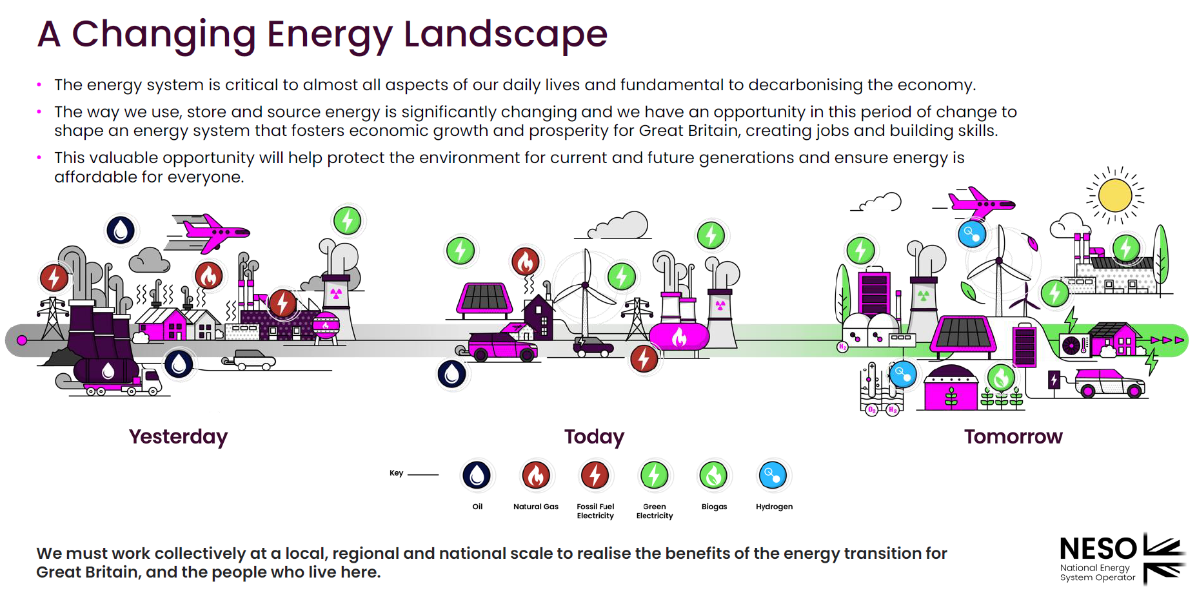
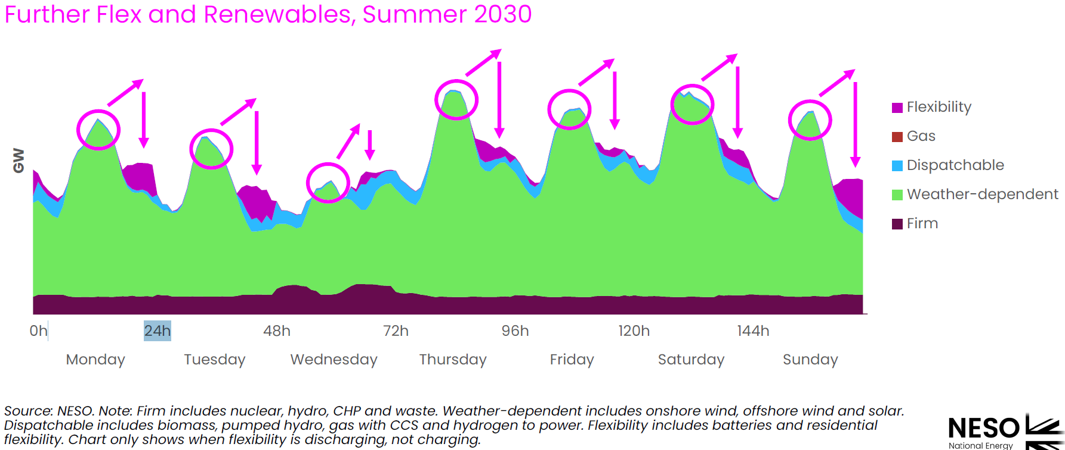
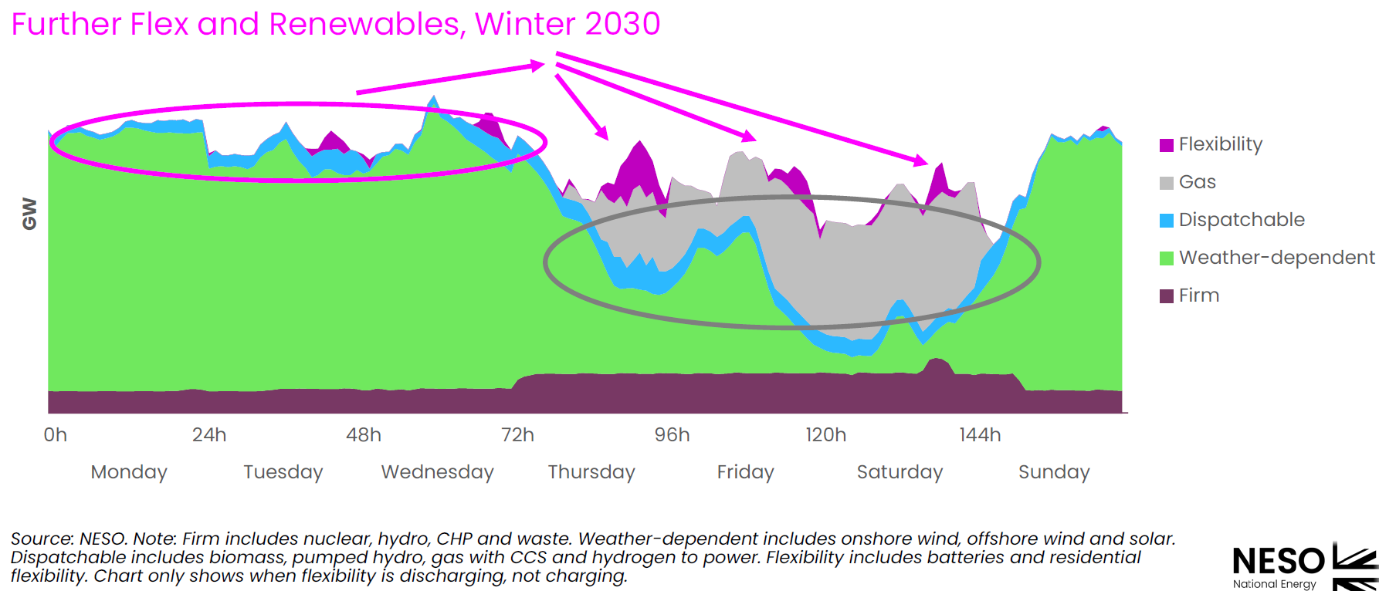
FLEXIBILITY NEEDs
Table 1 provides a summary of the major categories of flexibility needs, highlighting their respective timescales, spatial characteristics, and key drivers: These flexibility needs—and their interplay across spatial and temporal dimensions—form the backbone of clean energy system operability and should be integrated into infrastructure planning, market design, and operational protocols from the outset.
Flexibility Need | Timescale | Spatial Scale | Key Drivers
Power Balancing | Seconds–Seasons | System-wide | vRES variability, residual load
Load Ramping | Minutes–Hours | Regional/Grid-level | Solar "duck curve", demand peaks
Congestion Management | Minutes–Hours | Local/Regional | DERs, network constraints
Frequency Regulation | Sub-seconds–Sec | Grid-wide | Low inertia from inverter-based RES
Voltage Regulation | Seconds–Minutes | Local/Feeder level | Bi-directional DER flows, reactive power
Load Restoration | Minutes–Days | Regional/System | Extreme weather, black start needs

[Clean Power 2030 Advice on achieving clean power for Great Britain by 2030]
https://www.neso.energy/publications/clean-power-2030
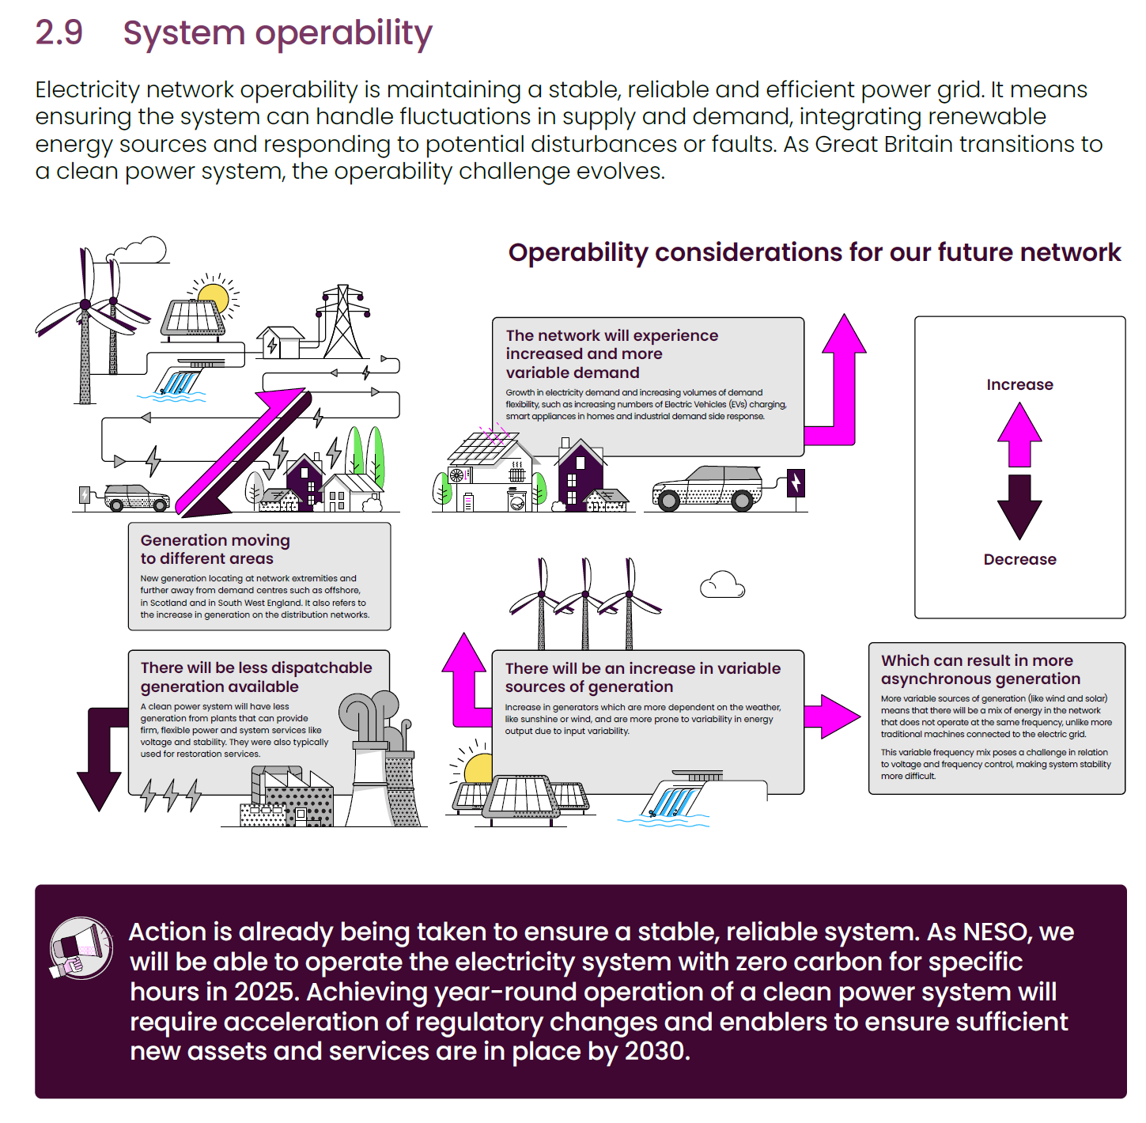
Traditional fossil-fuelled generation exhibits technical characteristics that have allowed system operators to successfully manage secure and safe electricity systems. As these types of generation decrease, the characteristics they have need to be replaced by other technologies and solutions.
In Great Britain, NESO has already taken big steps to prepare for a safe and reliable decarbonised electricity system. Through this work we understand the actions that need to be taken for reliability and safety, and we are confident that the cost of the provision of these services is lower than it would be on conventional power stations if they were only running to provide the services.
To operate a clean power system safely, securely, economically and efficiently requires resolution of operability challenges across stability, frequency, thermal constraints, voltage and restoration.
- Stability: To ensure the system can securely and reliably withstand unplanned events, for example the loss of a generator or a fault on an overhead line, there needs to be enough inertia and short circuit level. With the move to renewable generation, NESO needs to increase the number of technologies that can provide these services, such as additional synchronous condensers or batteries or renewable devices with grid forming inverters. With the establishment of our network services procurement (NSP) markets, we have the mechanisms in place to procure the services we need.
- Frequency: As there is less ‘inertia’ on the system, our ability to maintain the system frequency close to 50 Hz to balance real-time supply and demand requires a quicker response. NESO has already started this transition and our current services are pioneering in delivering the initial frequency response within one second. Hence, we are in a good place to understand how to manage the frequency of the system as we move to clean power. There will be a requirement to increase the volume of these services through our established frequency markets.
- Voltage: The voltage on the system must be maintained within acceptable operational limits using reactive power. All the new generation required to connect to deliver clean power must have a minimum range of voltage control; this includes battery energy storage and renewable sources of power. Voltage control in a clean power system does become more complex and further voltage control devices will need to be installed across the system to supplement the capability provided by the new connections. Working with the transmission owners (TOs), we will identify and secure/source these voltage control devices and services as required.
- Thermal constraints: In operating an efficient electricity system, there are times when the physical capacity of the network cannot transfer the amount of electricity required. When this happens, generation output on one side needs to be reduced and this is called a constraint. Network investment involves a cost of upgrading the network, but brings a benefit in reducing the costs of these constraints. On top of investment, the use of other commercial and technical techniques can reduce these costs. As we progress towards 2030, NESO will assess and deploy existing techniques as well as embracing new and innovative grid enhancing transmission solutions that increase the capacity of the network.
- Restoration: NESO has an obligation, by 31 Dec 2026, to be able to restore 60% of British transmission demand within 24 hours and 100% within 5 days after a shutdown. Clean Power 2030 pathways will not compromise this ability. The restoration strategy will include nontraditional generation for restoration services and an annual assurance framework to ensure compliance with the Electricity System Restoration Standard (ESRS).
Managing operability in a clean power system will require different and innovative approaches. NESO has begun making these changes and will work collaboratively with industry in developing and implementing them to run the future clean power system securely and efficiently. Our detailed operability analysis is presented in Annex 3.
[The Need for Flexibility in Power Systems]
https://www.linkedin.com/pulse/need-flexibility-power-systems-khalid-salman-khan-/
In recent years, there has been a growing recognition of the importance of flexibility in modern power systems. Flexibility refers to the ability of a power system to quickly and efficiently respond to changes in demand or supply, and is essential for maintaining the stability and reliability of the grid. In this blog, we will review the various factors that drive the need for flexibility in power systems and discuss the various techniques and technologies that are used to increase flexibility.
Factors Driving the Need for Flexibility. There are several factors that contribute to the need for flexibility in power systems:
- Increased penetration of renewable energy sources: As the share of renewable energy sources such as wind and solar in the energy mix increases, power systems must be able to respond to the inherent variability and uncertainty of these sources. This requires the ability to ramp up or down generation, as well as to provide frequency control and other ancillary services.
- Changing patterns of electricity demand: The increasing adoption of electric vehicles, as well as the growth of demand response programs, has led to changes in the patterns of electricity demand. This has made it more challenging to match supply and demand, and has increased the need for flexible generation and load management.
- Decentralization of power generation: The trend towards decentralized power generation, including the growth of distributed energy resources such as rooftop solar panels and microgrids, has increased the complexity of power systems. This has made it more difficult to maintain stability and has increased the need for flexible technologies and strategies.
Techniques for Increasing Flexibility. There are several techniques that are commonly used to increase flexibility in power systems:
- Ramping: This involves the rapid increase or decrease of generation output to meet changes in demand or supply. Ramping can be achieved through the use of fast-start generators, such as gas turbines or pumped hydro storage, which can be brought online or taken offline quickly.
- Load following: This involves adjusting the output of a generator to closely match the changing demand for electricity. Load following can be achieved through the use of controllable generators, such as hydroelectric or biogas plants, which can adjust their output based on demand.
- Frequency control: This involves the use of generators to maintain a stable frequency on the grid. Frequency control can be achieved through the use of spinning reserve generators, which are kept online but not generating power, and can be brought online quickly to respond to changes in demand or supply.
- Energy storage: Energy storage systems, such as batteries or pumped hydro storage, can be used to store excess electricity when demand is low and release it when demand is high. This helps to smooth out fluctuations in supply and demand and increase the overall flexibility of the system.
- Demand response: Demand response programs involve incentivizing consumers to reduce or shift their electricity use in response to changes in supply or price. This can help to reduce the need for ramping and load following, and increase the overall flexibility of the system.
Conclusion: Flexibility is an essential aspect of modern power systems, as it allows the system to respond to changes in demand and supply in a timely and efficient manner. The increasing penetration of renewable energy sources, changing patterns of electricity demand, and decentralization of power generation are all driving the need for flexibility in power systems. There are various techniques and technologies that can be used to increase flexibility, including ramping, load following, frequency control, energy storage, and demand response. Ensuring that power systems have sufficient flexibility will be critical for maintaining the stability and reliability of the grid in the face of these challenges.
[entso-e_System_Needs_Energy_Transition_v10]
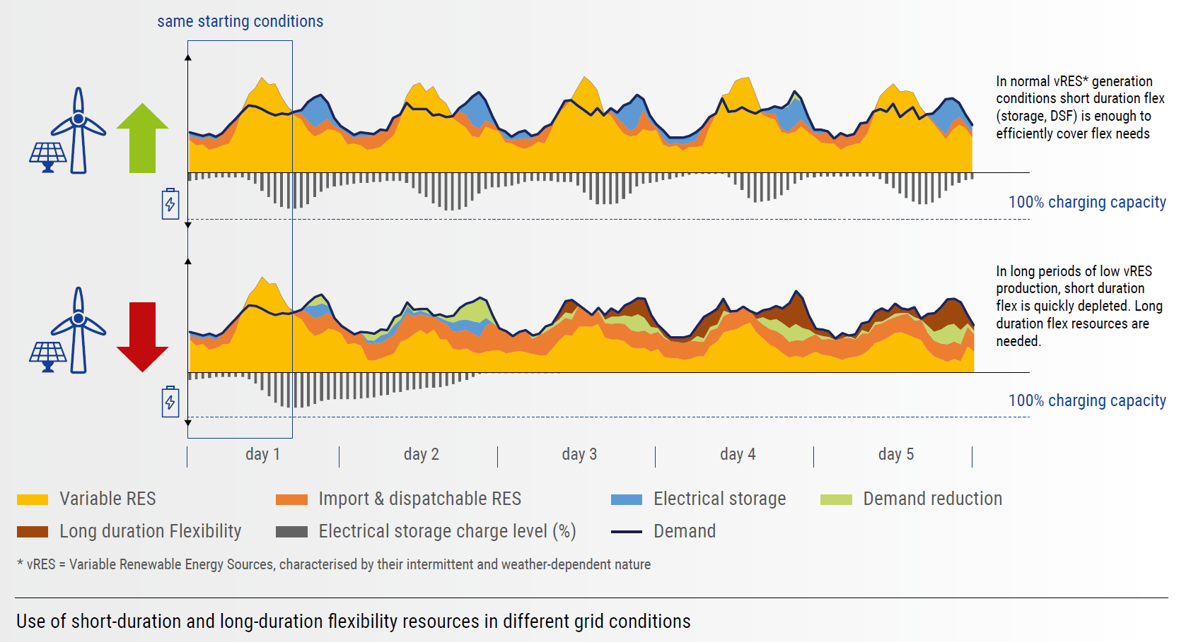
From a system perspective, flexibility needs can be categorised into several types, each requiring different resources. For the purposes of this report, we will consider the following flexibility indicators:
Long-duration indicator: Needs due to multi-day periods of variable renewable (vRES) shortage: This indicator focuses on identifying and characterising periods of prolonged renewable energy sources shortage, often referred to using the German term “Dunkelflaute”. These periods of prolonged vRES shortage often coincide with high electricity demand, leading to the depletion of storage and demand side response capacities, which typically require regular patterns of charge / discharge or usage. By examining these situations, this indicator aims to quantify the associated system needs and provide insights into the level of system stress experienced. It also assesses the effectiveness of interconnections in alleviating such stress.
Long-duration indicator: Needs arising from residual load variability up to the day-ahead: This indicator is concerned with the flexibility requirements arising from the variability of vRES and demand over annual, weekly, and daily timeframes. It helps in understanding how fluctuations in electricity production and consumption influence the system’s needs over different periods. Additionally, it begins to explore the flexibility demands related to residual load ramps, reflecting sharp changes in the difference between demand and vRES supply. This indicator’s goal is to quantify these needs and enable a deeper analysis of the drivers and contributions of interconnections in meeting these challenges.
Short-duration indicator: Needs due to forecast errors in the intraday timeframe: This indicator addresses short-duration flexibility needs arising from forecast uncertainties in vRES availability and demand after the day-ahead planning stage. By examining real-time deviations from planned electricity schedules, this indicator provides a detailed understanding of the operational flexibility required to respond to unexpected variations. It aims to offer insights into the necessary short-duration measures to maintain system stability in fluctuating conditions. The need for both short- and long-duration flexibility resources is explained in Figure 1 below. While efficient and capable of delivering substantial power, short-duration flexibility resources lack the energy storage capacity to sustain supply over several days. Thus, they must be complemented by high energy-density resources to cover long-duration needs resulting from variations over several days, weeks, or seasons.
[Flexibility in the GB Power System]
From a system point of view, flexibility needs can be structured under two main types, each requiring different flexibility resources: short duration flexibilities (from milliseconds up to a few hours, to balance the system within the day and ensure system stability), and long duration flexibilities (up to several weeks, to compensate for long periods with shortage of wind, solar and hydro generation). The need for both kinds of flexibility resources can be explained with the graphic below: short duration flexibility resources are efficient and can provide significant amounts of power, but do not have enough energy stored to last several days, and will have to be complemented by high energy-density resources.
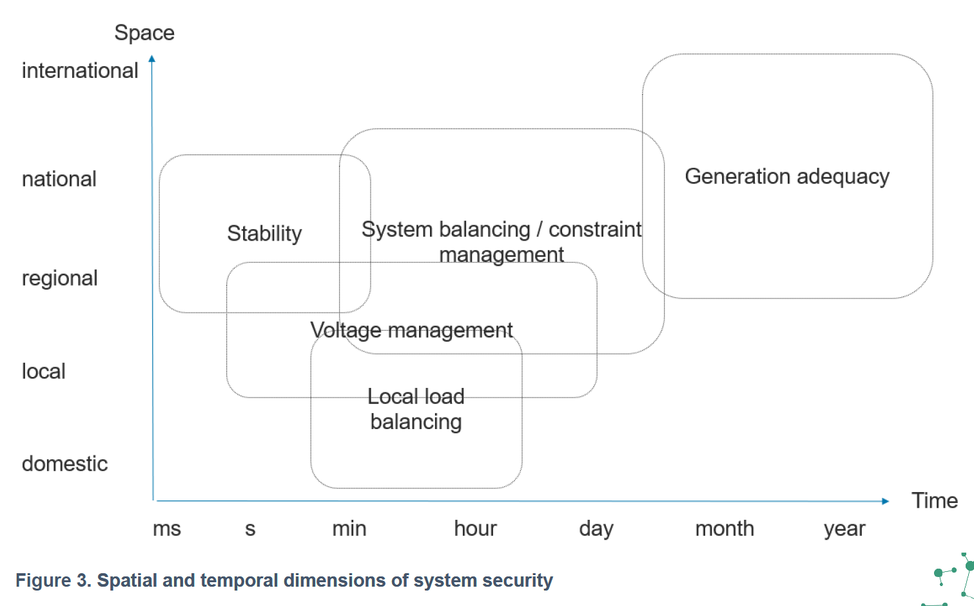
General adequacy: at the simplest level, adequacy is the question of whether there is enough generation capacity on a system to reliably meet peak demand. This comparison is usually made to inform investment decisions at long timescales to determine the need for new generation capacity.
System balancing: At a system-wide level, the amount of electricity generation entering the electricity grid must (after losses) be equal to the demand for electricity for the system to be in balance. Deviations from this will cause the frequency of the system to move away from 50Hz, and if this deviation is large enough, will cause disconnection of generators, leading to a further drop in frequency and, after a certain point, a cascade of disconnections and the possibility of grid collapse. To prevent this, the System Operator must take actions to ensure that the volume of generation on the system is continuously meeting demand, within the constraints of different forms of generation. This involves taking actions at a variety of timescales (days ahead to real-time) to increase/decrease generation and demand, and ideally doing so at the least cost - i.e. using the cheapest balancing actions procured through competitive markets.
Constraint management: the System Operator must also ensure that the resulting flow of electricity between generators and consumers does not breach the limits of any network assets, such as from the flow of power through an overhead transmission cable exceeding the thermal limits of that line and causing faults. In order to respect such limits, further balancing actions are required, such as by reducing the output of a generator at one end of a transmission line and increasing the output of a generator at the other end by the same amount, with the net effect that the overall balance of energy on the system is the same, but the flow across that particular network asset is reduced.
Local load balancing: The above system-wide requirements on balancing and network constraints also apply at a local level to distribution networks which transport energy from the main electricity grid to individual consumers through lower voltage levels of the system. This has additional complexity as generally at lower voltages (i.e. more localised areas of the network) far fewer network assets are actively metered, and the real-time state of network components may be unknown. In addition, an increasing volume of decentralised generation (e.g. small-scale renewables such as solar photovoltaics) is connected into local distribution networks, meaning that there is a growing requirement for the operators of those networks to actively manage their systems in the same manner as the System Operator does for the wider system.
Stability: As with System Balancing, the system must be kept in balance at all timescales – including on those (second and millisecond level) where human intervention is not possible. This means that the system must be capable of automatically responding to unexpected deviations. For example, if a single large source of power (such as a nuclear power station or interconnector) goes offline, with a resulting rapid drop in frequency, other sources must be capable of either increasing generation or decreasing demand to rapidly rebalance the system and curtail that drop in frequency. Historically this has been provided by traditional synchronous generation – i.e. large fossil-fuelled power stations which are grid-coupled and can automatically regulate their output against any change in frequency. Similarly, the existence of large thermal power stations has also bestowed the system with a high degree of ‘inertia’ – that is, the property of resisting changes in frequency – principally engendered by the mass of rotating turbines electromagnetically coupled to the grid. Hence any movement away from traditional thermal power generation means a loss of inertia on the system and a greater potential for any disturbances to have a larger impact on the wider system.
Voltage management: A feature of alternating current (AC) systems is that as well as active power (the component of electrical energy which can usefully do work such as powering light bulbs or turning motors) there exists ‘reactive power’ – an additional component which arises due to the exchange of energy between charging and discharging electric fields, and which provides no net gain or loss in power. As different components of the electricity system also consume or generate this reactive power, this must also be managed by the system operator, and manifests as the voltage found in different parts of the network. As with system frequency, voltages must be managed – via the control of reactive power injection and consumption – to remain within operational limits to prevent damage to electrical components. However, unlike frequency, voltage will vary across the system and must be managed locally. At a system level, the voltage across large-scale assets such as transmission power lines is managed via specialised equipment such as shunt capacitors, reactors and synchronous compensators. As the system transitions in the type of generation connected this will have further implications for reactive power and voltage management, potentially increasing the need for such assets. Similarly, at a local level, the introduction of new forms of demand (such as heat pumps or EV chargers) will affect local voltages and require additional management.
Loss of load expectation (LOLE): as a measure of system adequacy, the expected proportion of time that generation will be insufficient to meet demand. As firm dispatchable generation is removed from the system and replaced by less dependable sources of generation (either variable renewables, or interconnectors whose availability depends on the state of the system at the other end of the cables), the LOLE will increase for a given capacity of electricity generation on the system. This, in turn, creates a requirement for more controllable forms of generation and demand which can be utilised during periods of system stress.
Maximum in-feed loss: the largest infeed of power which may credibly be expected to disappear from the system without warning, and which the system must be capable of containing without undue frequency deviation. This is a function of the largest single sources of power on the system, typically either a nuclear power station or interconnector. For example, once Hinkley Point C is commissioned, this will represent a larger single point of failure (1.6GW of infeed) on the system than is currently (1.32GW) protected against, meaning that a larger minimum amount of reserve services must be continuously procured to protect against that possible failure.
[ISGAN_DiscussionPaper_Flexibility_Needs_In_Future_Power_Systems_2019]
In this report, flexibility needs are considered in a holistic manner, both from the overall system perspectives as well as from the more local perspectives:
- Flexibility needs from an overall system perspective are related to maintaining a stable frequency and a secure energy supply.
- Flexibility needs from a more local perspective are related to maintaining bus voltages and securing transfer capacities.
This means that flexibility needs and resources may be found in the whole power system. Needs for flexibility are not only limited to the balance of supply and demand but are also for relevant for maintaining voltages and securing transfer capacities. It is important to understand the flexibility needs to be able to identify and select the most suitable flexibility solutions and the resources which can provide the flexibility.
Examples of possible flexibility resources include: Operational and planning procedures; Synchronous conventional power plants; Power electronic interfaced renewable power plants; Grid infrastructure primary equipment; Grid infrastructure secondary equipment; Energy storage; Demand; Sector coupling.
When considering flexibility for both operation and planning of the power system, flexibility support is required in a timescale from fractions of a second (e.g. stability and frequency support) to minutes and hours (e.g. thermal loadings and generation dispatch) to months and years (e.g. planning for seasonal adequacy and planning of new investments).
Categorisation of flexibility needs are in this report done through four categories: Flexibility for Power, Flexibility for Energy, Flexibility for Transfer Capacity, and Flexibility for Voltage.
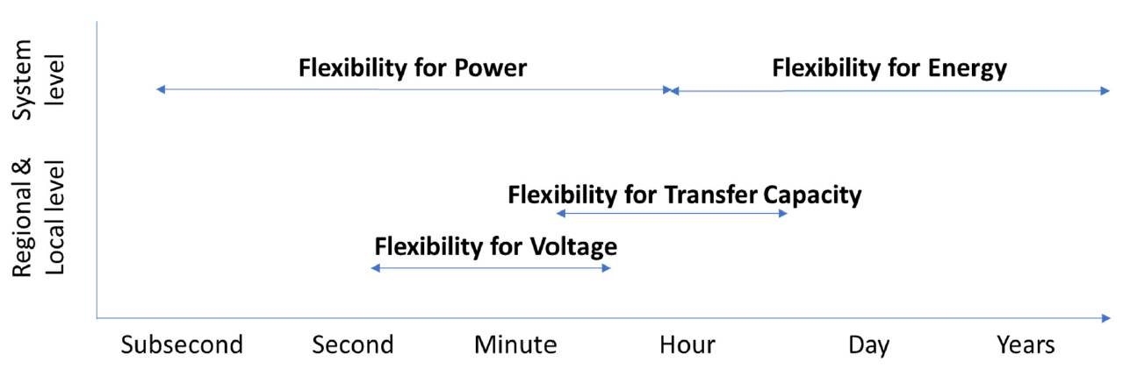
Flexibility for Power. Need description: Short term equilibrium between power supply and power demand, a system wide requirement for maintaining the frequency stability. Main rationale: Increased amount of intermittent, weather dependent, power supply in the generation mix. Activation timescale: Fractions of a second up to an hour.
A functioning power system is required to maintain the equilibrium between power supply and power demand at all times. For the short term, this corresponds to maintaining the system frequency within pre-defined limits in order to prevent frequency instability (in an AC system). Conventional means of maintaining the frequency relate to the control of active power of generation units within the synchronous area. This is defined as the units balancing capability (upward or downward, depending on the requirement of increasing or decreasing the power generation). The balancing capabilities within a system are defined by the flexibility of the generation units. Control of flow on DC connections to neighbouring systems may also be considered to provide a part of this balancing capability. Furthermore, system demand has also been part of the balancing capability through the incorporation of bi-lateral agreements with dedicated load centres to decrease their demand if required. Increasing the amount of intermittent weather dependent power generation, which results in the decrease of available plannable generation, increases the uncertainties and variability of the power supply.
Flexibility for Energy. Need description: Medium to long term equilibrium between energy supply and energy demand, a system wide requirement for demand scenarios over time. Main rationale: Decreased amount of fuel storage-based energy supply in the generation mix. Activation timescale: Hours to several years.
For the medium to long term, the equilibrium requirement between supply and demand implies the requirement to secure the supply of energy for future scenarios. Managing and maintaining a secure energy supply in the long-term perspective is complex and involves seasonal optimisation of the value of stored energy including forecasted outage periods for power plant maintenance, future load scenarios, etc.
Conventional solutions include stockpiling of fuels for thermal plants and the use of hydro reservoirs to reduce the impact of seasonal variations in precipitation and load. Seasonal variations in load are also considered when scheduling appropriate timing for the maintenance of the traditional base-load thermal units (such as nuclear and coal), in such way that long term flexibility is provided and thus maximising the availability for high demand seasons.
Pumped hydro is a flexibility solution for daily demand variations, to utilize available generation capabilities during hours with low demand in order to increase the amount of supply available for hours with high demand.
Photovoltaic (PV) solar energy production have a strong seasonal variation in countries far from the equator and has a negative correlation with weather dependent loads in colder climate.
Decreasing the amount of fuel storage-based energy supply (such as nuclear and coal) and increasing the amount of non-fuel storage based energy supply (such as solar and wind), increases the uncertainty of the future energy supply. To be able to maintain a secure future energy supply, in a medium- and long-term perspective, there is an increased need for flexibility solutions to provide possibilities of storing energy from situations of high supply to situations with low supply.
The flexibility need categorised as flexibility for energy is required to support the system in the multi-hour, daily, seasonal and annual perspective.
Flexibility for Transfer Capacity. Need description: Short to medium term ability to transfer power between supply and demand, where local or regional limitations may cause bottlenecks resulting in congestion costs. Main rationale: Increased utilisation levels, with increased peak demands and increased peak supply. Activation timescale: Minutes to several hours.
Dealing with power system security, the topology and capacity of the power grid plays a most important role. As grids are typically dimensioned and planned in a socio-economic way, with available grid capacity placing restrictions on operation and operation planning. Thus, flexibility does not only relate to the ability to balance supply and demand, but also to the location of reserves to be activated given a certain disturbance or unbalance and the grid capacity between the demand and supply.
Flexibility is, to a certain extent, a built-in functionality in the power grid itself. In an AC system, the use in operation of real-time or anticipated changes in grid topology (so called “remedial actions”) is a well-known and cost-free flexibility resource. Besides, other measures which provide increased transfer capacities or flexibility in the control of the power transfer system are available in operation like increasing nominal voltage levels, or the use of phase-shifting transformers. At the grid expansion planning stage, series-compensation, or, power electronics based Flexible AC Transmission Systems (FACTS) devices can be installed. They can be used to control voltage, re-direct power flows or to improve stability properties.
New installation to strengthen the power transfer may not be possible or justifiable from different perspectives. Such limitations may occur locally and regionally, influencing the power system on a national and international level. In such cases, other solutions to increase the flexibility for transfer capacity may be needed to cope with increasing peak transfer situations.
Dynamic line rating (DLR) for overhead lines increases the flexibility in utilization of assets, where the use of measurement system solutions provides ambient dependant utilization levels of lines instead of predetermined fixed ratings. Utilizing dynamic rating for other assets, such as cables, may be future solutions which may increase the flexibility to cope with peak transfer situations.
Power systems are usually operated and planned in accordance with the n-1 reliability criterion, implying that no single contingency should result in a large disturbance. The n-1 criterion imposes restrictions on power transfer, where e.g. thermal or stability limits of lines places constraints on transfer on parallel connected lines in a power transfer corridor. Such limitations may lead to bottlenecks in the system and result in regional price difference for customers or limitations on generation. The n-1 criterion is quite simple to implement but does not consider the relative probability or the consequence of a specific outage.
Furthermore, power systems may be subject to multiple or “cascading power transmission outages”. Such outages may propagate nonlocally; after a fault occurs on one component, the next fault may be very distant, both topologically and geographically. In the end, such propagation may get out of control and lead to system wide blackout. In order to avoid such events, additional restrictions may be imposed on power transfers in which case limitations are due to security concerns rather than thermal ratings.
The use of probabilistic reliability criteria instead of, or as complements to, the n-1 deterministic criteria could provide additional flexibility for transfer capacity and further increase the available grid capacity.
Flexibility for Voltage. Need description: Short term ability to keep the bus voltages within predefined limits, a local and regional requirement. Main rationale: Increased amount of distributed power generation in the distribution systems, resulting in bi-directional power flows and increased variance of operating scenarios. Activation timescale: Seconds to tens of minutes.
Maintaining the bus voltages within predefined levels throughout the power system is important both from a stability perspective as well as for power quality.
Voltage stability is largely related to the reactive power capabilities of generation units, and other reactive power compensation units, and the location of such units. The behaviour of demand, as well as the operation of distributed generation units, has a strong influence on the voltage.
FACTS devices, such as static var compensators (SVC) or static synchronous compensators (STATCOM), are increasingly important as means for TSOs or DSOs to control voltage and at the same time being flexible and independent of services from generators.
The increased amount of distributed generation creates completely new power flows in the system, altering voltage profiles in the distribution system and may lead to decreased power quality. To be able to maintain the bus voltages within predefined levels, there is an increased need for flexibility solutions to provide voltage support.
Ancillary services from distributed generation and storage may become useful solutions for distributed voltage support. Demand side response solutions may be used in a similar way.
Broadening of acceptable ranges for power quality may also prove to be suitable solutions for flexibility. Such changes could lead to increasing requirements on components and systems within the power system.
The flexibility need categorised as flexibility for voltage is required to support the power system on a local and regional level, which means that the location of resources to provide the flexibility is highly important. The timescale relevant for flexibility for voltage is from seconds to tens of minutes.
Quantifying the need of flexibility in the power system. Since flexibility may be defined in a variety of ways, it is difficult to quantify the total need of flexibility. Instead, limiting the focus only to a certain type of flexibility may allow it to be quantified. Some of the quantifiable dimensions of flexibility are: Power - physical capability to deliver, e.g. the size of the flexible active or reactive load, expressed in MW or Mvar. Response time - the time until the flexibility can be delivered, e.g. related to start-up time of a power plant, expressed in seconds-minutes-hours-days-years. Speed - the rate of which the flexibility can be delivered, e.g. emergency ramp rate of an HVDC, expressed in e.g. MW/s. Duration - how long the flexibility can be provided, e.g. the time span for overload rating of a component, expressed in seconds-minutes-hours etc. Energy - merging the power and duration dimensions, expressed in e.g. MWh. Recovery period - the time interval needed to provide flexibility after it has been fully utilised, e.g. the time to fully charge an empty energy storage, expressed in seconds-minutes-hours etc.
[POWER SYSTEM FLEXIBILITY FOR THE ENERGY TRANSITION]
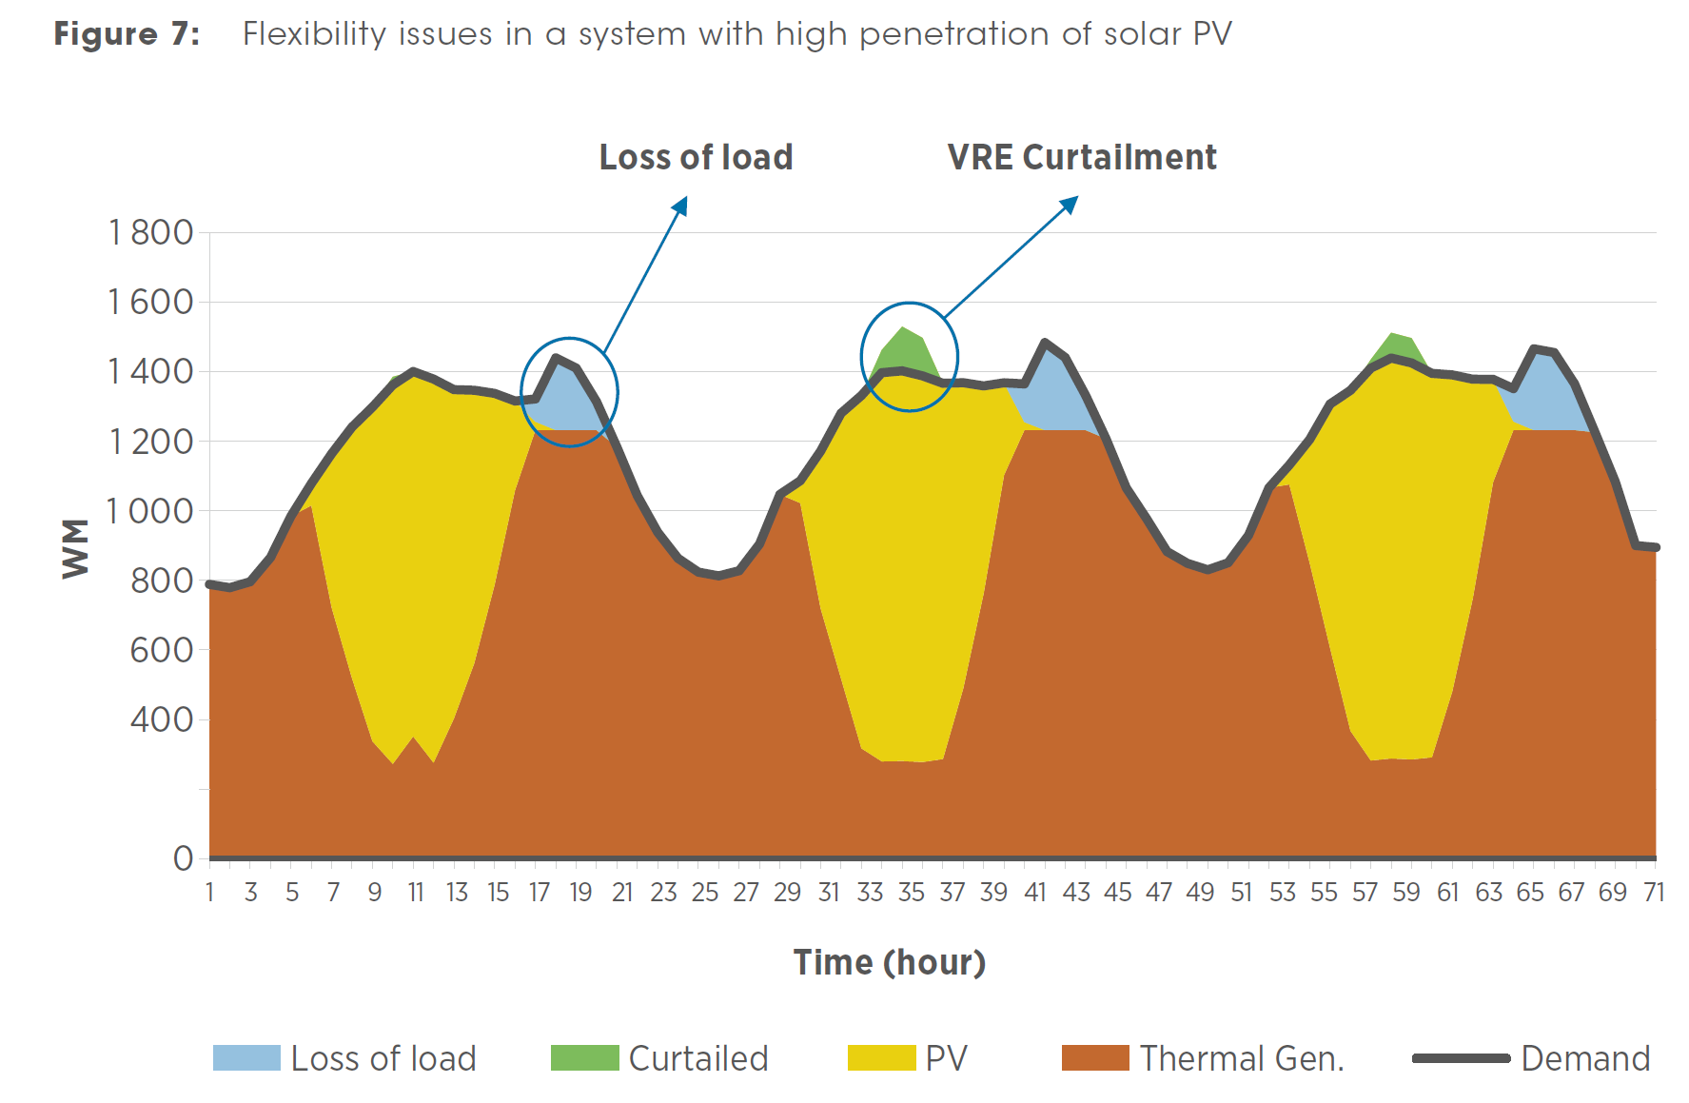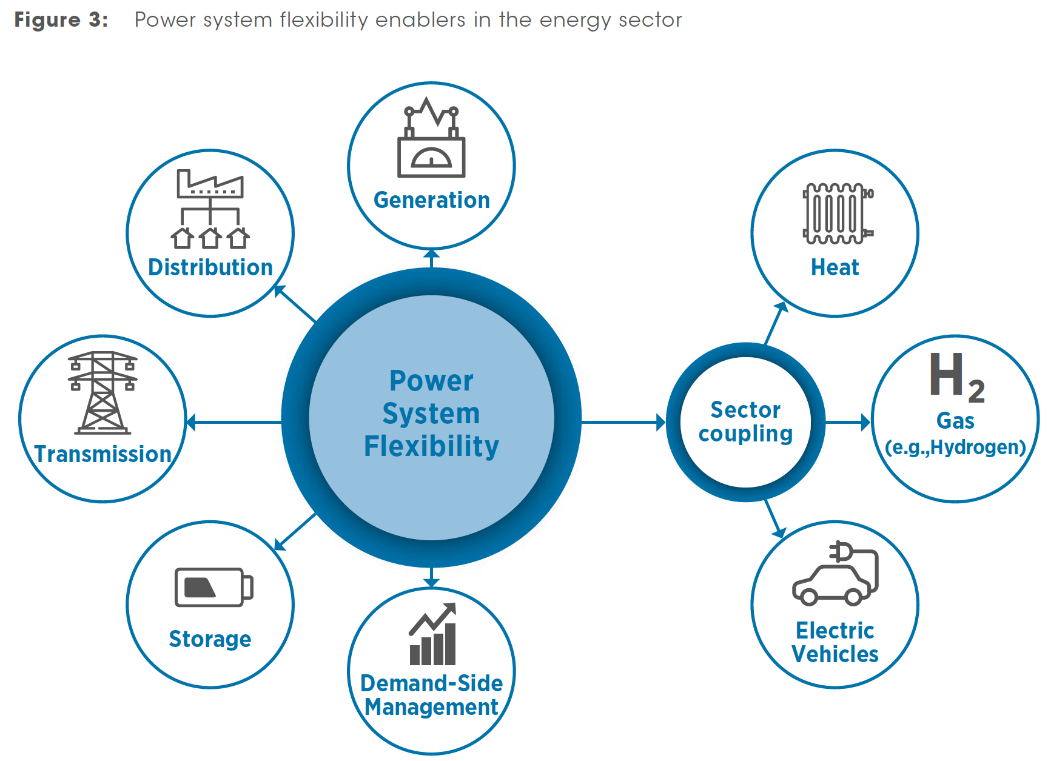
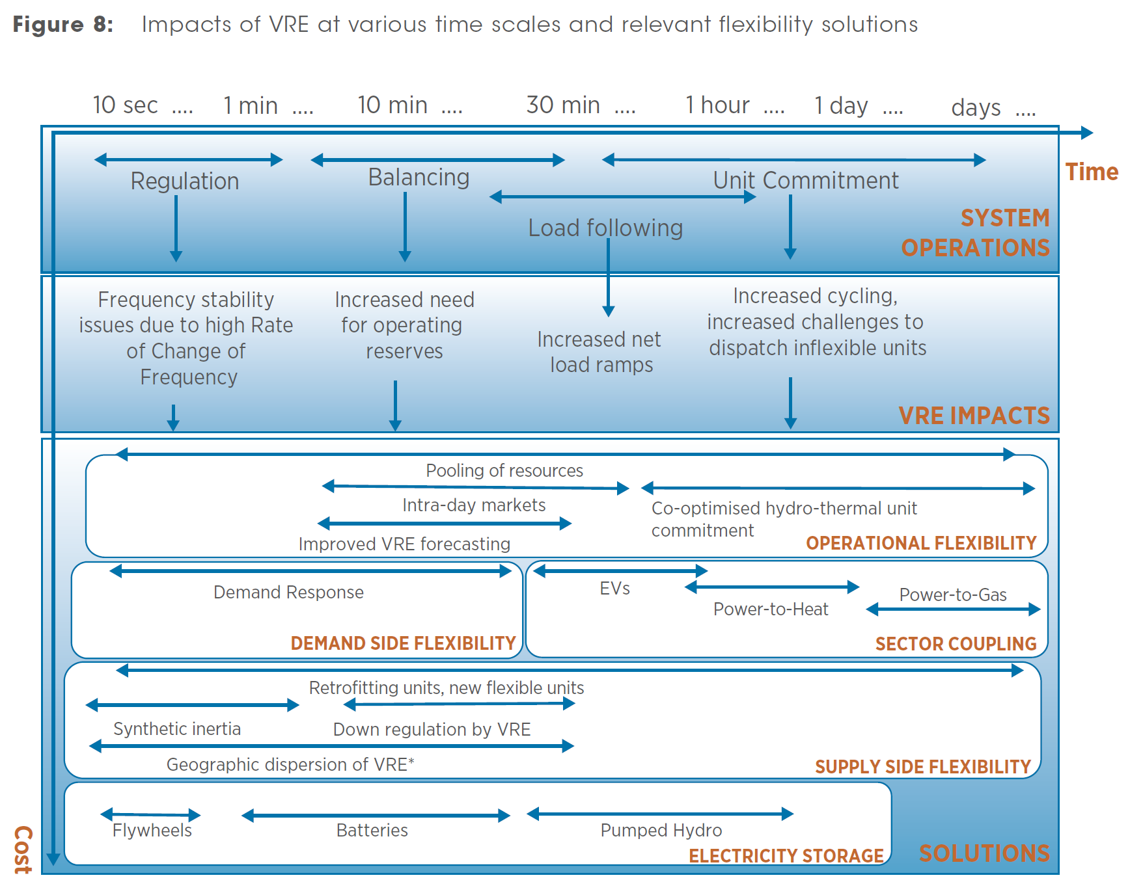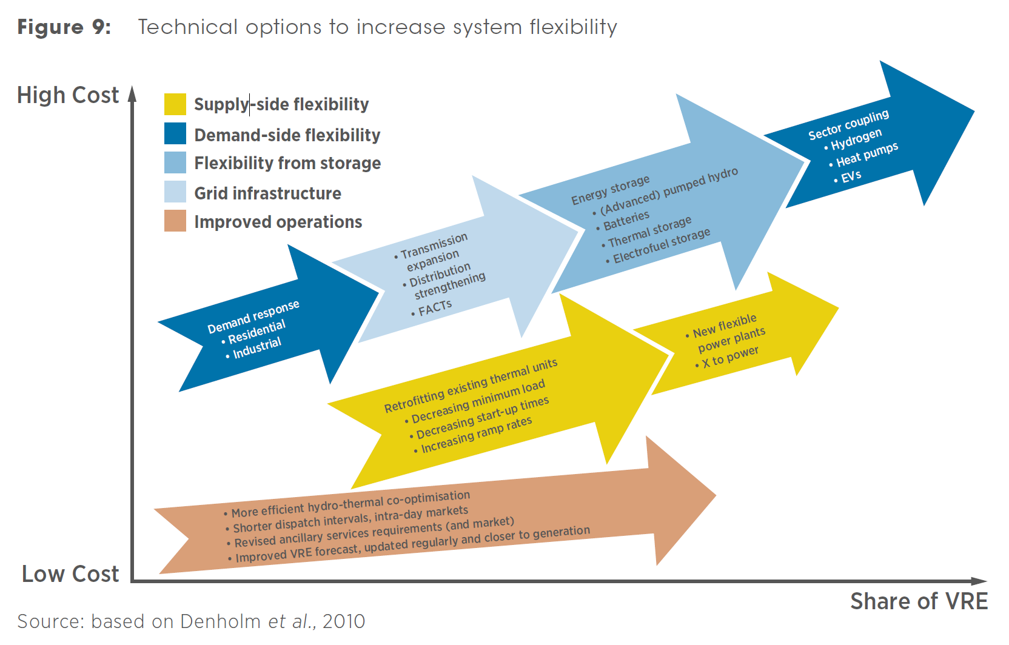
VRE curtailment is a mitigation measure that is usually applied when a system cannot cope with down ramping requirements. Similarly, upward ramping challenges are experienced during late afternoon hours when solar PV production is reduced towards sunset. Lack of system flexibility during upward ramping might lead to loss of load. Loss of load together with VRE curtailment are indicators that are frequently used in VRE integration analysis to assess a system’s flexibility.
Flexibility resources need to be managed by the system operator, which has two main ways to procure the services it needs for reliable and secure system operation: grid assets can be required to provide specific services, or, if they are owned by market participants, they can be incentivised to do so through markets for energy and ancillary services. If both fail, then the system operator may be forced to resort to VRE curtailment or load shedding. The failure may be due to insufficient requirements or incentives for the market participants, but it also may be caused by actual deficit in necessary assets, which would be the result of regulatory failure in providing long-term incentives for investment in the necessary assets (e. g., in case of no capacity market and no scarcity pricing allowed).
A power system can be considered flexible if it can cost-effectively, reliably and across all time scales:
1) Meet the peak loads and peak net loads, avoiding loss of load. (If the installed generation is lower than the peak demand, peak loads will not be met. In this case there is not a flexibility issue but a generation adequacy problem. A system is flexible if it can meet peak loads under the assumption that the generation mix is adequate.)
2) Maintain the balance of supply and demand at all times, and ensure the availability of sufficient capability to ramp up and down, the availability of sufficient fast-starting capacity and the capability to operate during low net loads.
3) Have sufficient storage capacity (both electricity storage and, through sector coupling, renewable heat and gas) to balance periods of high VRE generation and periods of high demand but low VRE generation.
4) Incorporate capabilities to adjust demand to respond to periods of supply shortages or overgeneration.
5) Maintain capabilities to mitigate possible events that could de-stabilise the power system through maintaining an adequate supply of ancillary services at all times (Reserves are spare capacity that the dispatched units have to keep in order to compensate an imbalance between supply and demand. For instance, if there is a sudden increase in demand, generation should rapidly increase, and this is achieved with upward reserves. The reserves considered here control system frequency, which is a direct measure of the active power balance. Voltage is a local phenomenon and needs to be controlled by assets close by. Increasing the share of VRE, especially generation connected at low voltage levels, can cause voltage issues, but this also can be mitigated by VRE assets that can participate in voltage control).
6) Operate under a well-designed market where existing flexibility is not locked by market inefficiencies.
[Status_of_Power_System_Transformation_2018]
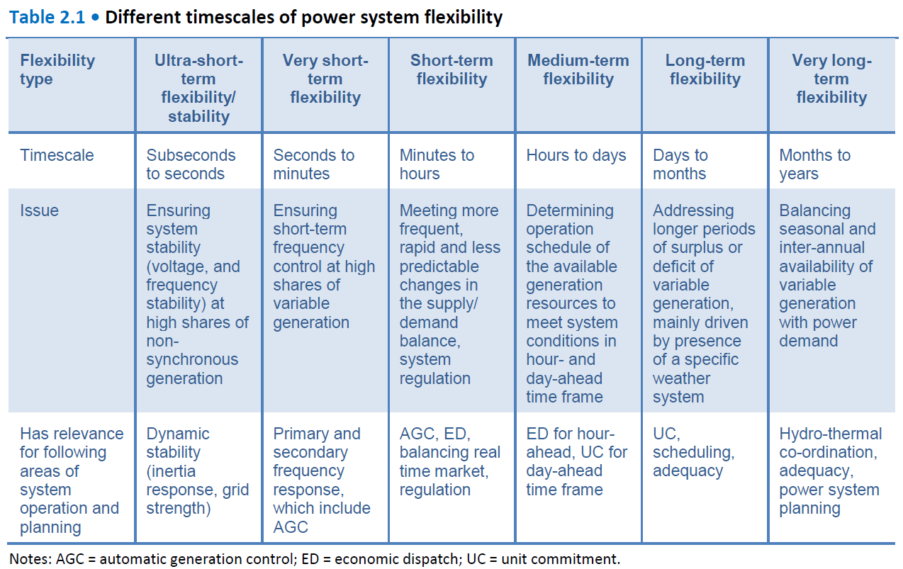
As regards the short term, these flexibility needs are driven by technical power system characteristics relating to voltage and frequency management, which are essential to system stability. Longer-term flexibility needs come from weather system and seasonal drivers and are related to the availability of appropriate capacity and resources.
For the short timescales in this report, the focus is on system frequency, while the voltage aspect is not covered in detail. Any imbalance between supply and demand results in frequency deviation, denoting either supply surplus or deficit. System frequency is one of the critical considerations in determining appropriate technical and regulatory options, particularly as the share of VRE increases.
For longer-term flexibility, the issue of uncertainty in the future resource mix is also relevant since it is related to ongoing investments. One important consideration is that the non-VRE mix should be sufficiently robust to accommodate an uncertain VRE penetration rate, which may differ from the plan. The task of promoting adequate power system flexibility grows increasingly complex as levels of VRE increase.
Box 2.1 • Deriving different flexibility timescales
Fundamentally, flexibility needs cover a continuous time spectrum from the nearly instantaneous to years. However, to help understand the basis of these needs, as well as the different mechanisms for meeting them, it is helpful to group flexibility requirements on the basis of timescale ranges. In this report, six separate timescale categories are considered, although categorisations with both fewer and more divisions can easily be applied.
Ultra-short-term flexibility/stability covers timescales from subseconds to seconds and focuses on arresting immediate frequency deviations during the transition to frequency nadir. In other words, this refers to limiting the rate at which the frequency deviates from its standard operating range. Ultra-short-term flexibility is the time period before the frequency nadir (Figure 2.1). The key source of ultra-short-term flexibility is the inertia provided by synchronous generators, where the physical spinning mass of the generator resists changes in power system frequency.
Very short-term flexibility then covers timescales from seconds to minutes in order to return frequency to its standard operating range (Figure 2.1). This includes the response on the scale of seconds from generator governors, where frequency is detected locally and generation output can be autonomously adjusted without external input (for example, droop response), and also includes processes that involve an external control signal, such as AGC.
Short-term flexibility covers periods from several minutes to hours, from the fastest market-based adjustments up to typical ED horizons (Figure 2.1). AGC is applicable in the timescale of several minutes. ED is also applicable from minutes to hours, depending on the structure of the market. On these timescales, increased VRE can increase the extent and frequency of changes in the supply-demand balance, and also has implications for the predictability of these changes. This is driven by both predictable patterns in VRE output (high solar output in the middle of the day, stronger wind resources in the evening and at night) and by the partial unpredictability of VRE output due to weather forecast uncertainty.
Medium-term flexibility ranges from the timescale of hours to days, which involve both ED and UC. ED is applicable to the hour timescale while UC mostly covers the day timescale, but can also touch upon the hour timescale. In this medium term, the operation schedule is determined on the basis of the reliability and economics to meet the expected system conditions in the hour- and day-ahead schedule. With increased VRE penetration, ED and UC play an important role in accessing the physical capability of power plants in order to enhance system flexibility.
Long-term flexibility covers the timescale of days to months where weather system patterns become a driver for flexibility needs. Particular weather conditions often persist for several days, with impacts on both electricity demand and supply, due to weather-driven heating and cooling needs and impacts on VRE output. UC is still applicable in this timescale, particularly from day to week.
Very long-term flexibility extends a similar principle to monthly and yearly timescales. Both electricity demand and VRE output can have strong seasonal patterns. Increasing VRE penetration results in flexibility requirements to balance supply and demand on a seasonal basis where, for example, there may be a mismatch between the time of the year with the strongest VRE output and the highest system demand. Beyond this, interannual flexibility is also an important consideration, with VRE and hydropower resources often showing significant interannual variations (e.g. via the El Niño phenomenon). Long-term flexibility issues are often considered and designed out during power system planning processes.
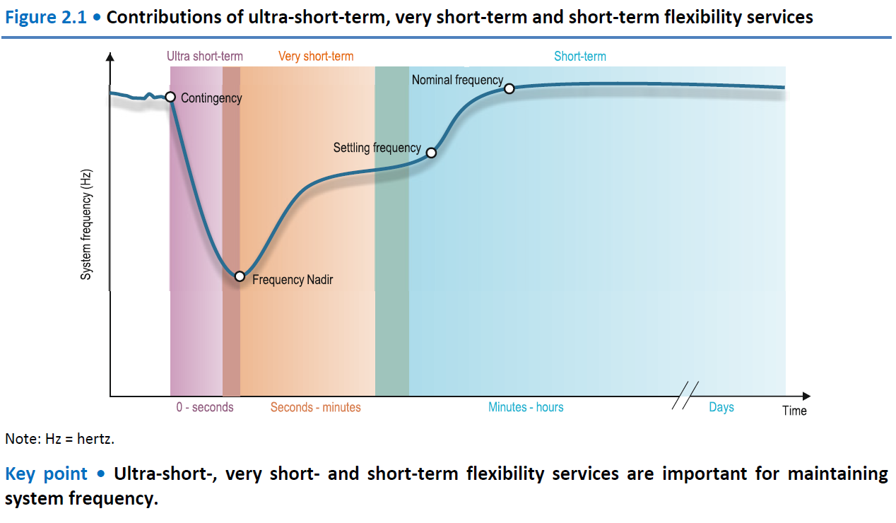

System balancing requirements: second by second for sudden surges in TV use or up to months at a time managing the differences in energy demand and supply between different seasons, for example higher gas network demands in winter.
Frequency and voltage stable: generation always needs to match demand second by second to maintain such stability.
Unplanned events and security of supply standards in electricity systems: there is sufficient generation capacity held. The Security and Quality of Supply Standard (SQSS) sets out the reliability standard for the electricity system, currently three hours per year loss of load expectation (LOLE).
Security of supply standards in gas system: balance every day. For gas, there is no direct equivalent to LOLE, however the N-1 condition is used as a guide. There must be enough supply to meet the peak demand on a very cold day (a 1-in-20 peak winter day), even if the single largest piece of supply infrastructure were to fail.
Power quality: Provision of short circuit level data: Power quality is critical to the performance of the plant and equipment connected to the power network. Poor power quality can reduce efficiency, cause excessive heating, or even damage the assets. Driven by the net zero targets, the penetration of inverter-based resources (IBR) will continue to increase, reducing the system strength in certain areas of the network. There is a direct correlation between system strength, traditionally measured by the short circuit levels (SCL), and some power quality aspects, including harmonics, voltage unbalance, and voltage flicker. This report discusses the main aspects of power quality in the future GB transmission network. This paper explores options for defining and referencing the short circuit level (SCL) for new and existing connections to the GB electricity system. As more non-synchronous generations connect to the electricity system, a reduction in traditional synchronous generators impacts system stability. We describe why the short circuit level is important and explore several options for defining its requirements for new and existing generation. We are also seeking industry feedback on which of these options provides the optimal solution for defining short circuit level. https://www.neso.energy/publications/system-operability-framework-sof
On the generation side, flexibility may entail ramping the power up or down to meet demand; energy may also be stored for later use, and used to produce alternative products such as thermal, electrical, or chemical energy, depending on the required time and power demand. On the use side, demand response approaches may be employed to shift demand when possible, thereby reducing peaks, slowing ramp rates, and limiting stress on the grid. [intro-sections.pdf]
In general, the electricity grid employs daily scheduling of slow ramping sources on the 12- to 24-hour timescale based on day-ahead weather and load forecasts. Load following occurs on the order of minutes to hours. Regulation occurs on the order of seconds to minutes (NREL 2011).
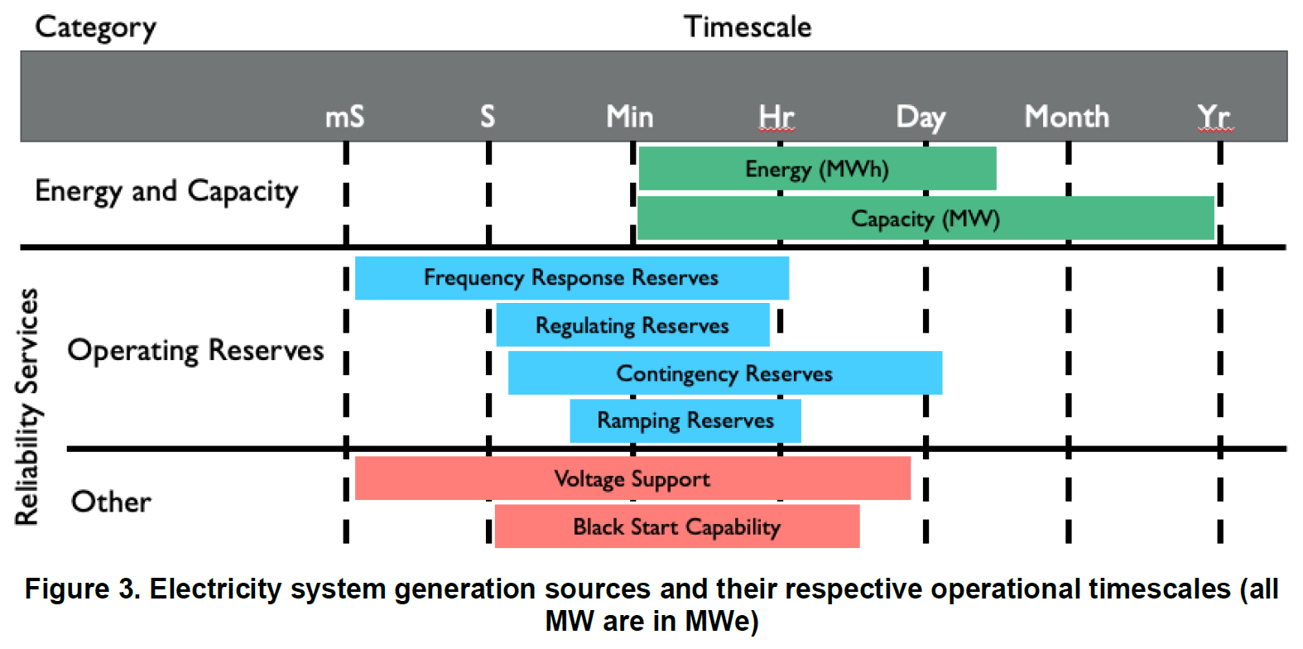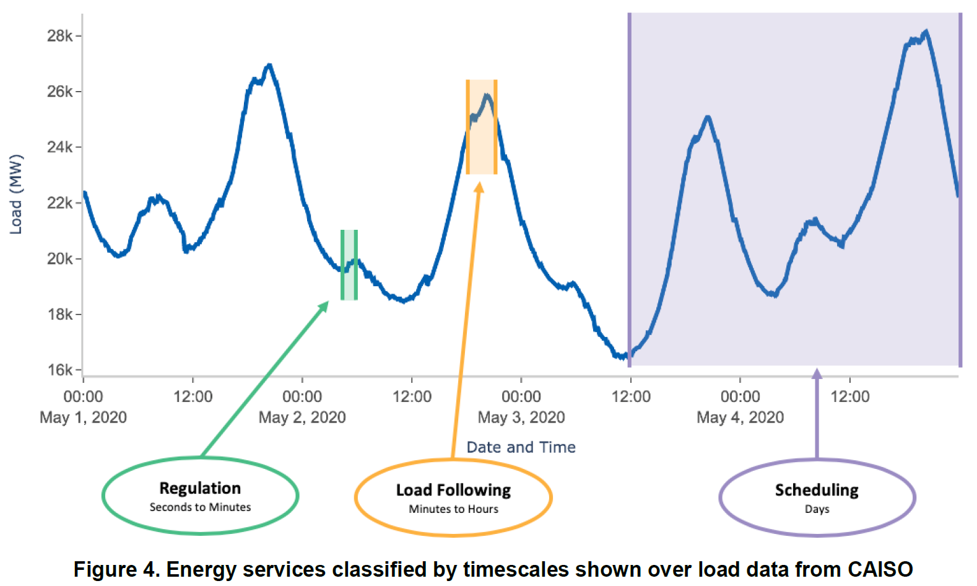
[Power System Flexibility – a key enabler for the energy transition]
https://www.hitachienergy.com/news-and-events/perspectives/2023/11/power-system-flexibility-a-key-enabler-for-the-energy-transition
Flexibility is the ability of power systems to cope with variability and uncertainty at all times.
Definition of flexibility. We have done some extensive research into the exact definition of power system flexibility, and it is quite remarkable how many different interpretations there are. This underscores our aim to delve deeper into this interesting topic. We conceptualize flexibility as the ability of power systems to cope with variability and uncertainty at all times. A flexible power system is key to managing operations during normal conditions and times of high probability disturbances, always ensuring sufficient security of supply. Flexibility solutions are able to respond at any length of duration, stretching from milliseconds to years, and encompass power system stability, reliability and adequacy (see figure 1). The future power system will need to adapt quickly to any operational change, may it be the unplanned outage of a large power station or a high ramp-up or down in weather-dependent renewable energy output. Whether the event occurs suddenly for just a few minutes or will last for weeks over the high-demand period, the aim always needs to be a resolution at the lowest cost and with minimum impact on consumers.
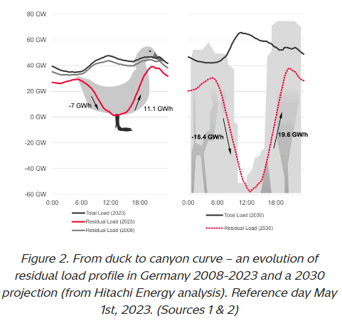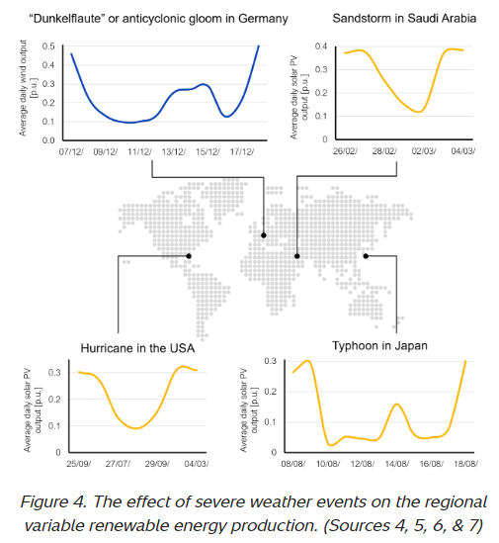
A flexible power system can effectively re-establish supply-demand balance following any change.
Measuring flexibility. With flexibility becoming so important, how can we measure it to identify potential shortfalls and anticipate future flexibility needs? We believe that the simplest measure to quantify how flexible a power system is lies in determining how effectively it can re-establish a supply-demand balance following any change. How quickly can the system’s flexible capacity ramp up or down at times of renewable supply shortage or overproduction? It’s also important to assess whether the system can quickly and economically address short as well as long-duration occasions of imbalance in supply and demand and that it could, in an extreme situation, meet the highest demand peak.
Residual load ramping challenge. When defining flexibility, it is also important to understand the rising prevalence of residual load. Whereas in the past, electricity demand was largely predictable throughout the day, the fast-growing connections of fluctuating renewable energy capacity, especially solar PV, has created a deepening distortion between when electricity demand is highest and when generation peaks. Residual, or net, load is defined as the total demand on the power grid minus the electricity production from variable renewable energy sources. Managing residual load is becoming increasingly important because it is characterized by incredibly fast ramping, or rate of change on the grid. This is where flexibility resources are essential to minimizing curtailments of clean electricity. This change in the residual load profile has been especially pronounced in the German power market, which has seen installed solar PV capacity rise from around 6.1 GW in 2008 to more than 67.5 GW in 2022, a ten-fold increase over the period. By 2030, the German government is targeting installed solar PV capacity of 215 GW, indicating that the renewable energy source will continue deepening its impact on the German market. As a result, the residual load profile in Germany has evolved from the typical ‘duck’ shape to a ‘canyon’ shape, highlighting the market’s current steep ramping needs.
The impact of weather. Flexibility is now becoming front and center of the proactive power system needed in a carbon-neutral economy. Next to residual load impact, the increasing reliance on renewable energy output has also forced a direct dependence on weather conditions. Unexpectedly calm weather days can have huge impact on grid balancing needs, as well as a spell of sunnier-than-expected weather. Regional weather patterns pose unique challenges to electricity markets in various parts of the world. For instance, in the Middle East, sandstorms can severely disrupt solar photovoltaic (PV) production for extended periods of several days. Similarly, Europe experiences the 'Dunkelflaute,' a phenomenon characterized by reduced light and wind levels that slow down renewable energy production, often occurring during the high-demand winter months. Additionally, in some Asian countries, monsoons with their dense cloud coverage can result in prolonged interruptions in solar PV output. Simultaneously, weather conditions in other regions might cause an oversupply of renewable energy, exceeding the actual demand. This surplus can potentially lead to a significant curtailment of green electricity, a phenomenon which sits uneasily with global efforts to reach net-zero emissions goals. Curtailment is highest in power systems where flexibility measures are limited or non-existent and as renewable energy capacity is rising across the globe, flexibility tools will become increasingly important in preventing valuable green electrons from getting cut off.
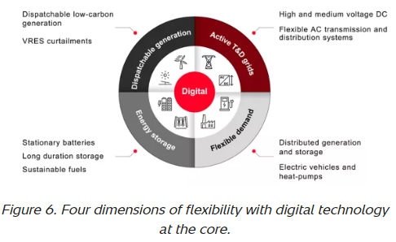
Digital tools are a catalyst for ensuring optimal input of all four areas of flexibility
The four dimensions of flexibility. We have identified four dimensions that we think are most crucial to dealing with the growing variability and uncertainty that a future carbon-neutral energy system brings: supply-side flexibility, demand-side flexibility, energy storage and active transmission and distribution grids. Digital technologies play a pivotal role in enhancing flexibility of power systems, acting as a catalyst for ensuring an optimal contribution of all four areas. It facilitates this across various time scales and locations, leveraging connected resources for maximum efficiency and adaptability. It's important to underscore the escalating necessity for dealing with variability and uncertainty in future power systems. This need is propelled by the ongoing energy transition toward decarbonizing power generation by integrating more weather-dependent renewable energy sources. Addressing the expanding variability in supply and demand requires harnessing both existing and emerging tools for flexibility.

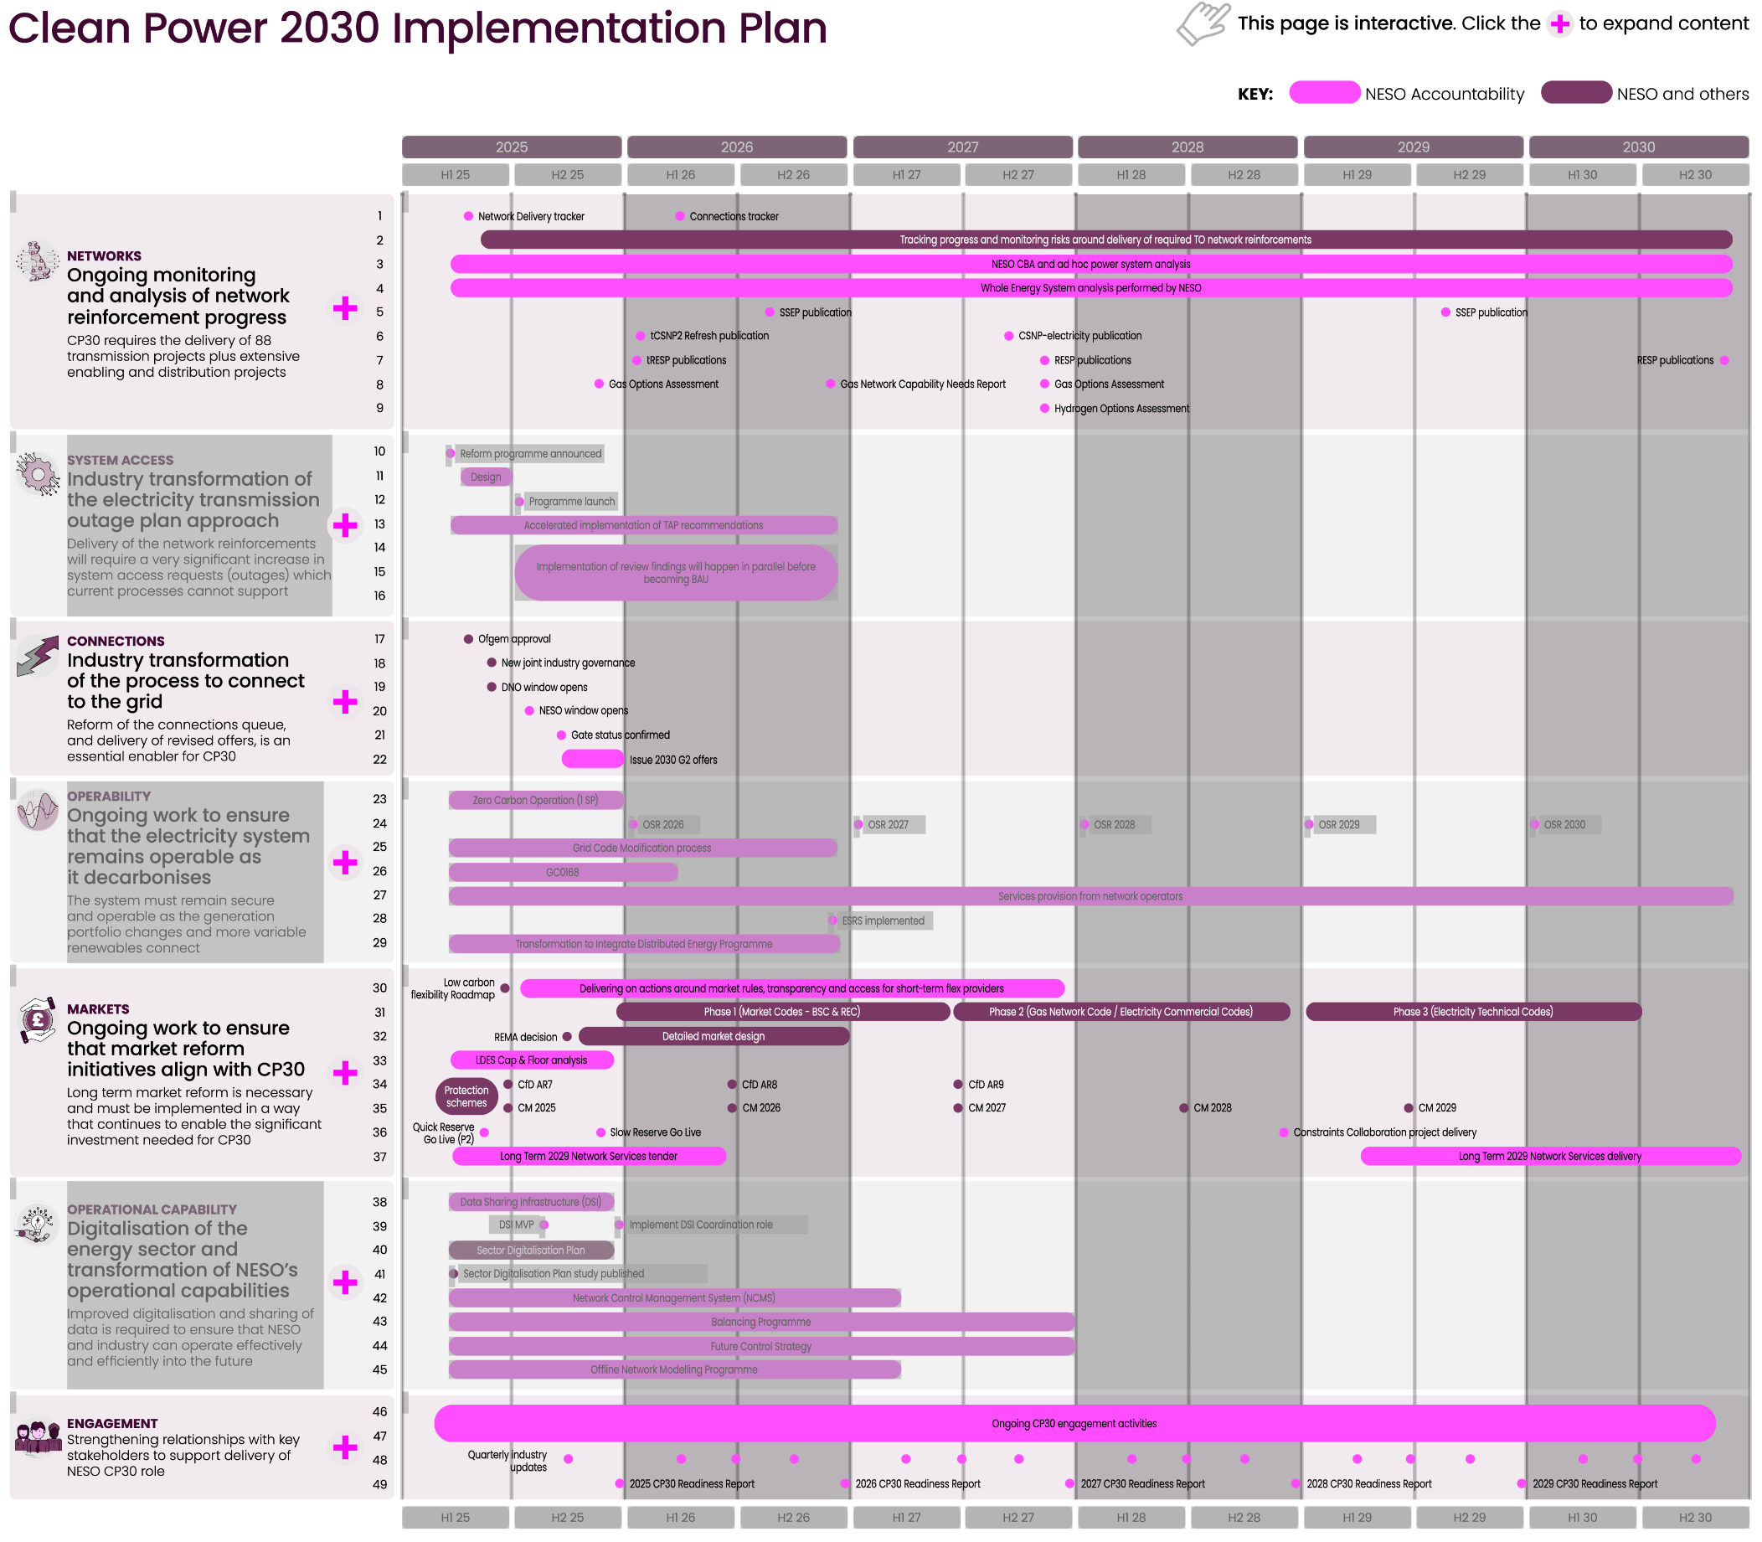

[ESO RIIO-2 Business Plan 2023-2025] Priority 7: Driving towards a whole energy system approach, Page 43.
Accelerating whole electricity flexibility. As the trend towards decentralised generation continues, and increasing volumes of DERs connect to the grid, we must continue to open our markets and services to new entrants that will play a critical role in delivering a secure, fair, and affordable net zero system for GB. Current market arrangements and frameworks do not currently provide the access that smaller distributed assets require - we are working with industry to address these barriers and to facilitate whole electricity system outcomes. We are already making good progress, for example through our RDPs and introduction of LCMs which enable revenue opportunities for DER. However, to achieve the level of DER participation that we require to achieve our net zero ambitions, we must accelerate progress. In BP2 we are focusing on four areas of activity across the whole business:
Facilitating market access for whole electricity flexibility: We will investigate how our markets can be designed and implemented to unlock the potential of distributed flexibility, for example through removing barriers for aggregators and energy suppliers, thereby facilitating DER assets in our markets.
Service coordination between markets: We will develop and embed processes and systems to coordinate markets across the whole electricity system. This will reduce the overall cost of managing electricity networks, ensure consumer value is realised and maintain continued security of supply. Moreover, this will support service providers’ access to markets.
Improved DER visibility: We require increased visibility of DER, as this will enable us to facilitate greater aggregation of DER services and enhance situational awareness, to allow better management of system events. To achieve this, we will work with industry and DSOs to deliver real-time visibility of DER, improve our processes for managing data relating to service providers, and expand the use of contractual arrangements.
Facilitating DSO: ESO/DSO coordination will be critical to achieve whole system operations and ensure a coordinated approach to operating in a highly decentralised sector. In BP2, we will build on the policies and procedures implemented in BP1, to further accelerate whole electricity flexibility. Additionally, from an operational perspective, we will focus on learning from real-time use of flexibility services.
Looking beyond ‘whole electricity’ to ‘whole energy’: The work we have described on managing growth in DER, our interaction with DSOs and investment in RDPs and LCMs will support the immediate need for a ‘whole electricity’ approach to system operation. As growth in these zero carbon technologies continues, and markets become increasingly deep and liquid, clear investment signals will usefully provide confidence for investors as they consider the trade-off between electricity, gas and hydrogen in seeking to solve the net zero challenge through a broader whole system lens. In BP2, our focus will be on flexibility, under these three key activities:
Ensuring operability of a zero carbon energy system: Our Operability Strategy Report sets out the challenges we face today in operating a rapidly changing electricity system and the capabilities and system requirements needed to resolve these. In BP2, as we work towards operating a zero carbon grid by 2035, we are taking a broader look, through a whole energy system perspective, by undertaking a rigorous and longer-term view of the requirements to meet the operational challenges as we decarbonise.
Transforming our capability in modelling and data management: We must transform our capability in modelling and data management to cater for a more complex system and facilitate zero carbon operation. We will do this in two parts: improving quality of system data and models through automation, and more broadly upgrading our modelling and tools for a more complex system. To be most effective in enabling a whole energy system approach, we must focus on foundational architecture for an interchangeable suite of tools - delivering a seamless data exchange for common data sets, and enabling more data and models to be shared. We will work closely with DNOs and other industry players to ensure we maximise the value of our work in this space.
Supporting whole system policy decisions: We will work with policy makers, regulators, and industry to develop the evolving future energy strategy, markets, and system needed for net zero. In our advisory role as FSO we will work with government on broader policy developments for example in relation to CCUS, hydrogen, long duration electricity storage and EVs. Additionally, we will continue to advise Ofgem and BEIS on the evolution of the network planning regime, for example working to optimise the connection of offshore wind farms and introduce competition to onshore transmission. Stakeholder engagement will be central to achieving this, for example on the integration of new technologies needed for effective zero carbon operation. We will bring our knowledge, insights and capabilities into decision-making forums and cross-industry working groups to help ensure that new technologies develop in line with system needs, thereby reinforcing our role as a trusted partner.
Read more about our activities in Driving towards a whole energy system (A1, A4, A13, A15) approach in our BP2 Delivery Plan.
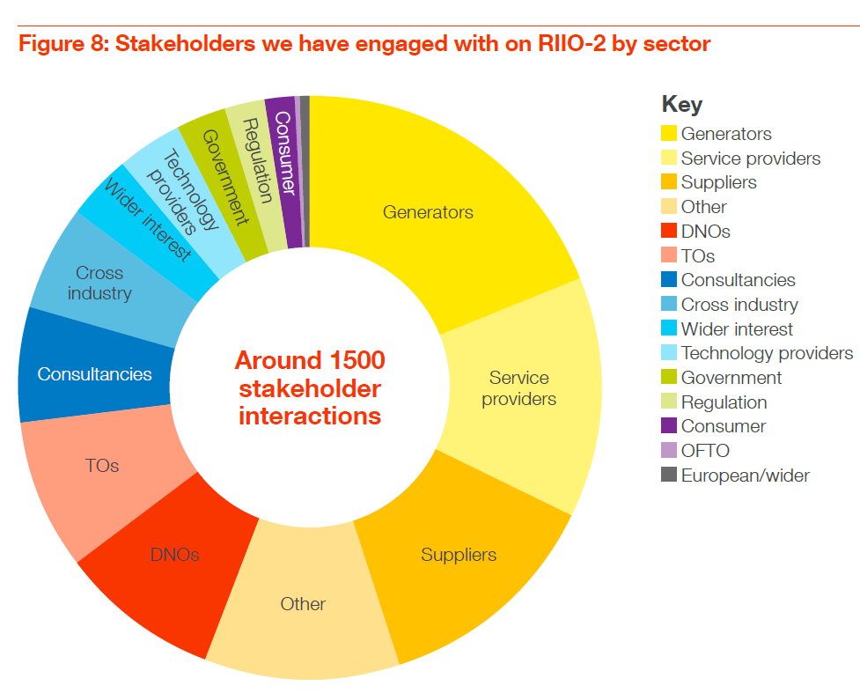

Fig. 1 | Flexibility needs in clean energy systems
Power balancing maintains the continuous real-time balance between electricity supply and demand.
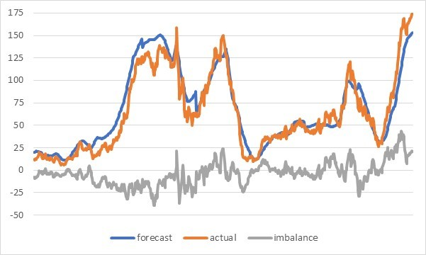
Figure 3: Forecast production, actual production and imbalance volume for a wind power portfolio in the first 7 days of January 2020.
https://www.kyos.com/ppa-insights-short-term-forecasting-and-imbalance-costs/
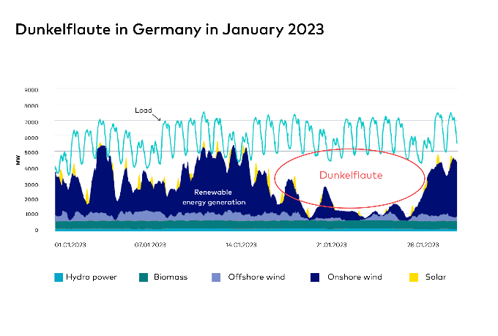
What is dunkelflaute?
https://www.gridx.ai/knowledge/what-is-dunkelflaute
https://storelectric.com/dunkelflaute-energy-storage/
Load ramping captures rapid changes in net electricity demand over short timeframes, primarily driven by fluctuations in vRES output.
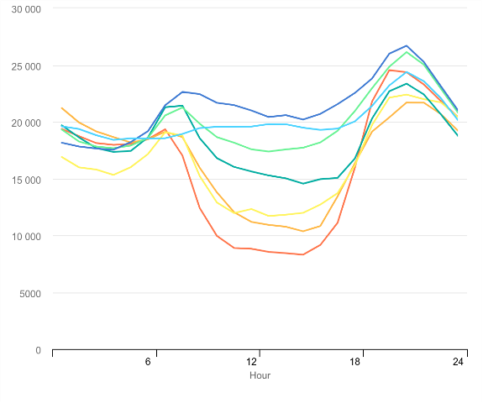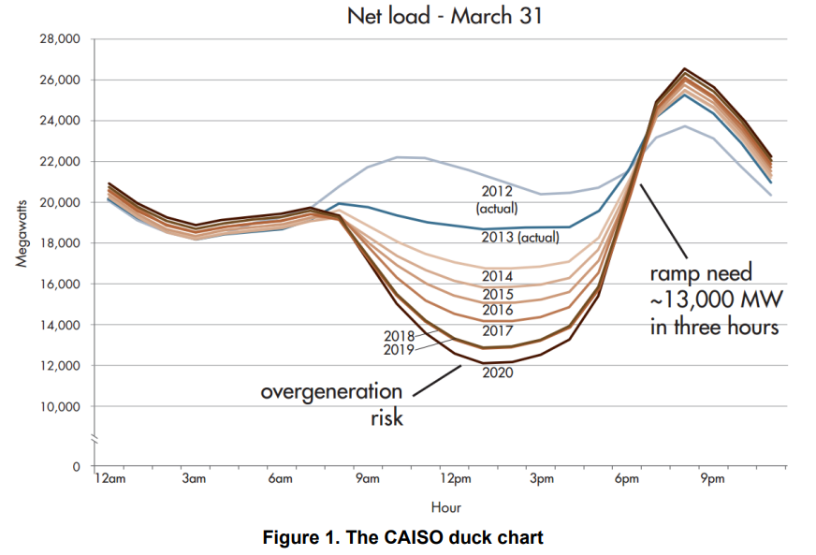
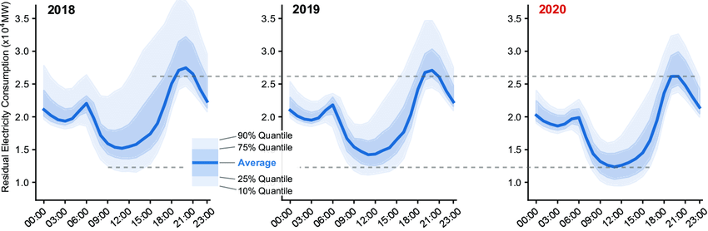
The California Duck Curve
https://www.iea.org/data-and-statistics/charts/the-california-duck-curve
Ten Years of Analyzing the Duck Chart: How an NREL Discovery in 2008 Is Helping Enable More Solar on the Grid Today
https://www.nrel.gov/news/detail/program/2018/10-years-duck-curve
Overgeneration from Solar Energy in California: A Field Guide to the Duck Chart
https://docs.nrel.gov/docs/fy16osti/65023.pdf
Quantitative assessment of U.S. bulk power systems and market operations during the COVID-19 pandemic
https://www.sciencedirect.com/science/article/pii/S0306261920317347
Flexibility for Residual Load
https://www.linkedin.com/pulse/flexibility-residual-load-gerald-kaendler/
Combined heat and power plant flexibility [LicentiatethesisJohannaBeiron.pdf]
Reducing Electricity System Variability with Solar Power
https://thruggles.com/archives/2021/09/2238/reducing-electricity-system-variability-with-solar-power/
Power System Flexibility - a key enabler for the energy transition
https://www.hitachienergy.com/news-and-events/perspectives/2023/11/power-system-flexibility-a-key-enabler-for-the-energy-transition
Congestion management addresses the need to maintain secure and efficient electricity flows within the physical and thermal limits of grid infrastructure.
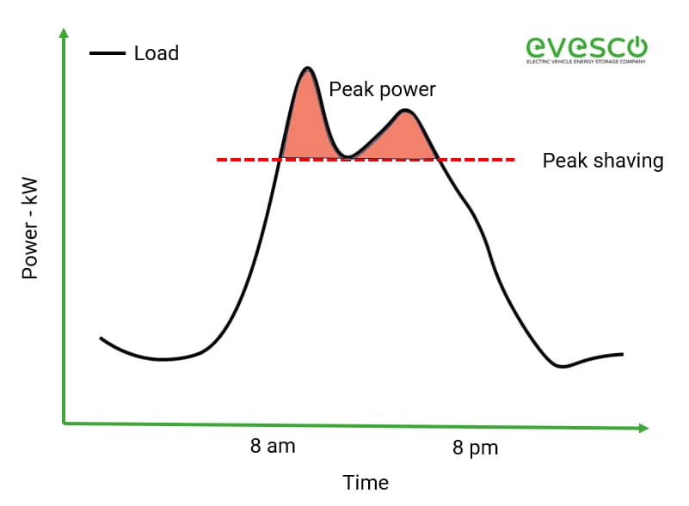
Grid congestion is posing challenges for energy security and transitions
The Netherlands is a striking example of a country where grid congestion has become a major bottleneck to the energy transition, challenging climate targets as well as energy security and affordability, as described in IEA’s recent Netherlands 2024: Energy Policy Review. The Netherlands is experiencing a rapid energy system transformation through impressive growth in renewable electricity generation and electrification of end-uses. At the same time, the country’s grid capacity did not expand sufficiently to accommodate all the new electricity demand and distributed supply. Furthermore, the net-metering arrangement provides payment for electricity delivered to the grid regardless of the market price, meaning that solar PV installations lack incentives to match the needs of the electricity system. This has resulted in grid congestion, an issue arising when electricity transfer capacity is not enough to transmit all available power from one point on the grid to another, and subsequent delays for adding or upgrading connections. In early 2025, there were around 10000 large users (consumers or batteries) and 7500 generation projects (larger than household-scale PV installations) waiting to connect to the Dutch electricity network.
https://www.iea.org/commentaries/grid-congestion-is-posing-challenges-for-energy-security-and-transitions
Frequency regulation refers to the continuous balancing of electricity supply and demand to maintain system frequency – typically at 50 or 60 Hz.
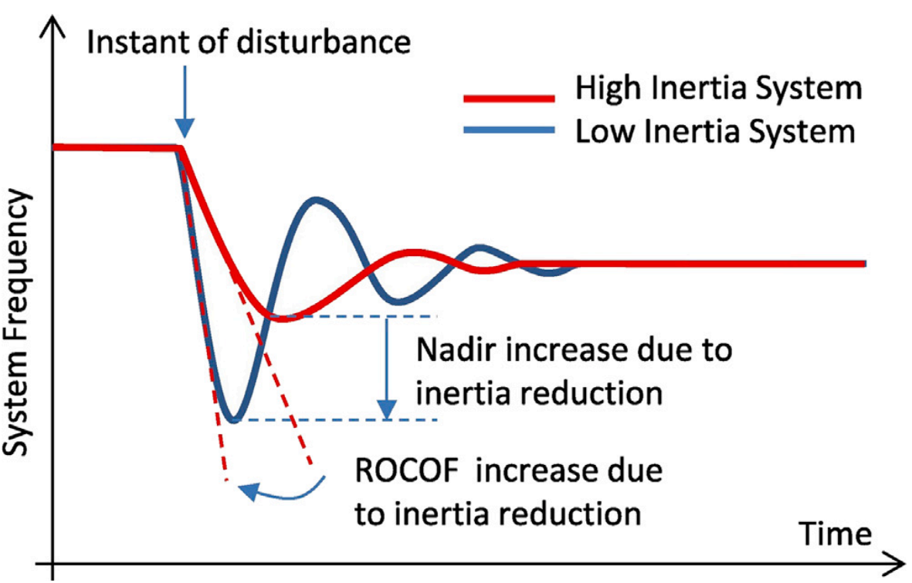
Australia’s Power System Frequency: Current Situation, Industrial Challenges, Efforts, and Future Research Directions
https://ieeexplore.ieee.org/document/10273444/
Frequency dynamics of the Northern European AC/DC power system: a look-ahead study
https://ieeexplore.ieee.org/document/9721592
Voltage stability is essential for maintaining power quality and grid reliability, requiring voltage levels to remain within acceptable operational limits across the power network.
Voltage regulation in low voltage distribution networks with unbalanced penetrations of photovoltaics and battery storage systems - Malta has seen challenges with grid integration of residential PVs, leading to overvoltages and reverse power flows. They are exploring the use of battery energy storage systems (BESS) as a solution.
https://ietresearch.onlinelibrary.wiley.com/doi/10.1049/stg2.12155
Experimental validation of a low-voltage regulator model - A case study of a Maltese low-voltage feeder
https://www.a-eberle.de/en/special-publications/experimental-validation-of-a-model-for-low-voltage-regulators/
https://ietresearch.onlinelibrary.wiley.com/doi/10.1049/rpg2.12933
Voltage Stabilizers in Africa
https://watfordcontrol.com/voltage-stabiliser-africa/
Voltage Stabilizers in Cameroon
https://watfordcontrol.com/voltage-stabiliser-cameroon/
Load restoration during extreme events is a growing flexibility need in clean energy systems.
What led to the historic collapse of the electricity system in the Iberian Peninsula?
What are the main characteristics of the Spanish and Portuguese electricity systems?
Portugal has a population of approximately 10 million, Spain has a population of 48 million. Portugal has approximately 20,000 MW of power plant capacity installed in its system, while Spain has approximately 120,000 MW, the distribution of which by energy source is shown in Figure 1. Half of Spain’s capacity comes from conventional power plants, a quarter from solar energy, and a quarter from wind energy. There are no nuclear power plants among the conventional capacities in Portugal, while Spain has seven nuclear power plant units with a total capacity of 7,100 MW.
An important feature of the Iberian Peninsula compared to the internal parts of the continental European electricity grid (e.g. Central Europe) is that this area is essentially a “dead end”: it is connected to the Moroccan network by a single submarine cable to the south, but to the French system by only two 220 kV, two 400 kV and one direct current cable (see Fig. 2). In this sense, it is more isolated than the interior of Europe, which means that it is less able to rely on cross-border capacities when dealing with operational disruptions.
https://www.euronuclear.org/news/what-led-to-the-historic-collapse-of-the-electricity-system-in-the-iberian-peninsula/
https://demanda.ree.es/visiona/peninsula/demandaau/total/2025-04-29
https://en.wikipedia.org/wiki/2025_Iberian_Peninsula_blackout
https://www.reccessary.com/en/news/spain-portugal-power-outage

Fig. 2 | Flexibility technologies in clean energy systems
Supply-side flexibility technologies (2): clean dispatchable generation, large-scale electricity storage, and grid interconnectors.
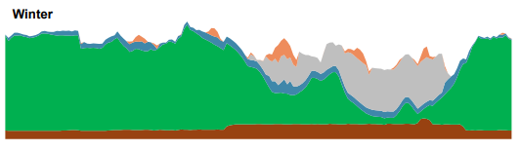
Clean dispatchable generation. HM Government has an ambition for Great Britain to be supplied with clean power by 2030. National Energy System Operator (NESO) was formally commissioned by the Secretary of State and the Department for Energy Security and Net Zero (DESNZ) to provide independent advice on the pathway towards the 2030 ambition. We developed a range of pathways, with expert analysis of the location and type of new investment and infrastructure needed to deliver it.
Clean power by 2030 is a huge challenge that will only be met by doing things differently, by prioritising pace over perfection, and by working together across the industry towards a shared vision. Our engagement goes beyond the energy sector, ensuring we take a whole system view.
https://www.neso.energy/publications/clean-power-2030
https://www.neso.energy/document/346791/download
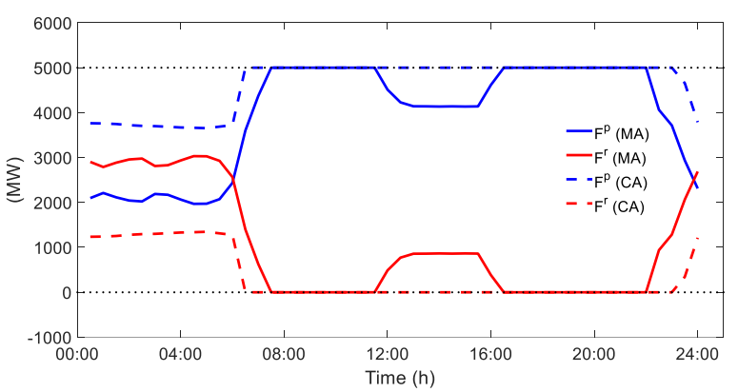
Value of Interconnectors Operating in Simultaneous Energy-Frequency Response Markets
https://ieeexplore.ieee.org/stamp/stamp.jsp?tp=&arnumber=9664289
Demand-side flexibility technologies (2): residential, commercial, industrial, and transport end users.
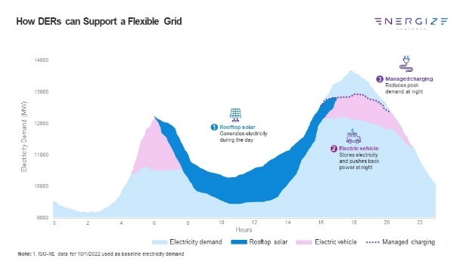
Electrifying Everything: Let's Get Flexible
https://www.energizecap.com/news-insights/electrifying-everything-lets-get-flexible
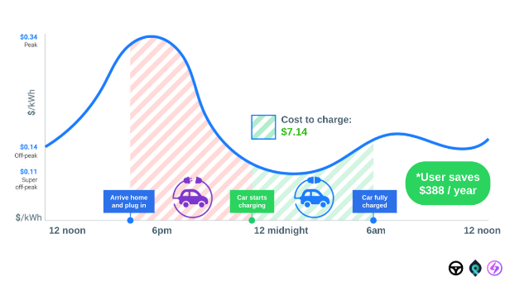
How to optimize EV smart charging for stronger grids and revenue
https://smartcar.com/blog/ev-smart-charging
Multi-energy flexibility technologies (4): power-to-X (P2X) conversions, gas networks and linepack storage, and district heating with thermal energy storage.
Power-to-hydrogen: Hydrogen can provide (a lot of) flexibility. So why bother with power-to-hydrogen if it is so inefficient? Well, for one hydrogen can provide flexibility. Something that is extremely useful with an ever-growing share of intermittent and seasonal renewable energies.
Short-term flexibility: Electrolyzers are quick to start up. Thus, they can be switched on in times of excess electricity supply to stabilize the grid and lower the need for curtailment. Vice versa, in times of low production hydrogen can be converted into electricity fairly quickly. Today, it is mostly natural gas power plants that provide this flexibility.
Transfer energy between seasons: Hydrogen is cheap to store in large quantities and unlike batteries does not lose energy over time. In Germany, for example, energy demand is 30% higher in winter than in summer. Energy supply from renewables, however, is 50% lower. Hydrogen could be used to level this, transferring the abundant clean energy from summer into winter.
https://www.gridx.ai/blog/power-to-hydrogen-explained
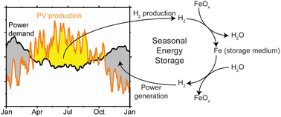
Safe seasonal energy and hydrogen storage in a 1:10 single-household-sized pilot reactor based on the steam-iron process
https://pubs.rsc.org/en/content/articlelanding/2024/se/d3se01228j
Power-to-hydrogen as seasonal energy storage: an uncertainty analysis for optimal design of low-carbon multi-energy systems
https://www.sciencedirect.com/science/article/pii/S0306261920307091
Potential of P2H technologies to provide system services
https://www.entsoe.eu/2022/06/28/entso-e-publishes-a-study-on-flexibility-from-power-to-hydrogen-p2h2/
Economics of converting renewable power to hydrogen
https://www.nature.com/articles/s41560-019-0326-1
Combined heat and power (CHP) systems are designed to be highly efficient as they capture and utilize the heat that would otherwise be wasted in traditional power plants. CHP systems can be fueled by a variety of sources, including natural gas, biogas, and biomass, and can be used in a variety of applications, including residential, commercial, and industrial. Nearly two-thirds of the energy used for typical separate power and heat generating is lost as heat during production, transmission, and distribution. CHP can reach efficiencies of over 90%, compared to about 52% for traditional systems, by capturing and utilizing heat that would otherwise be wasted and by eliminating distribution losses (e.g., conventional electricity generation and an on-site boiler). CHP systems can produce fewer carbon emissions than separate heat and grid power because of their higher efficiency.
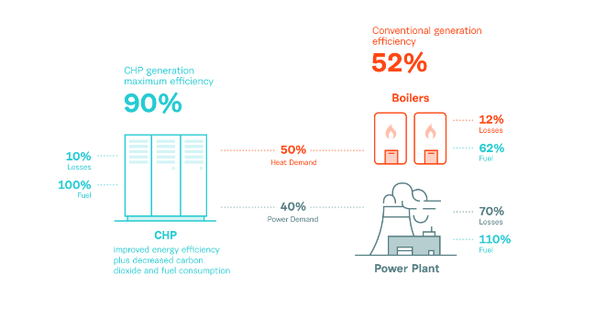
https://nanoenergies.cz/slovnik/combined-heat-and-power-chp
Module 19: Mini combined heat and power applications. The mini-CHP unit would normally be selected to match the base heating load of the site (as shown in Figure 3) to maximise the running hours. The success of all forms of CHP depends on the integration with the building’s heating system – particularly with engine-based technologies. Matching the CHP unit to the base thermal load must be the priority (that is, the system should be sized on a heat-led basis and not primarily on the electrical load). The CHP unit must be installed as the lead heating appliance, with existing or new boiler plant providing additional capacity to satisfy peak demand.
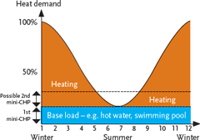
https://www.cibsejournal.com/cpd/modules/2010-08/
Plant Sizing. The CHP unit is designed to provide baseload electrical or thermal output, with any shortfall being supplemented by electricity from the grid or hot water/steam from boilers. The graph below shows an example of this with the blue area representing baseload thermal energy. Due to the relative prices of fuel and electricity, electrical baseload sizing though is the more common. The most cost-effective solution, however, may be to size above baseload (see red dashed line on graph), even though this would obviously involve some heat dumping.
https://www.esru.strath.ac.uk/EandE/Web_sites/97-8/chp_sizing_case/plant.html
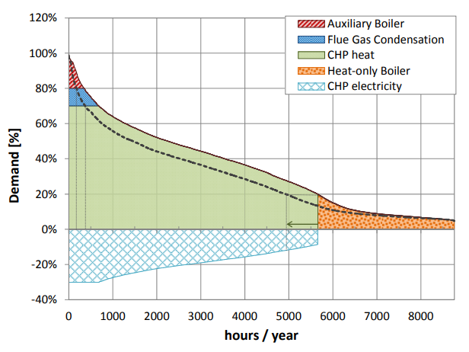
Assessing the techno-economic impact of low-temperature subnets in conventional district heating networks
https://www.sciencedirect.com/science/article/pii/S1876610217322804
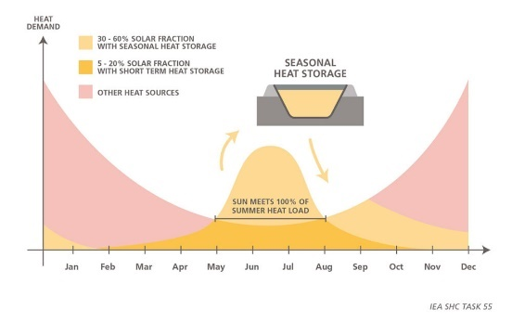
Pit Thermal Energy Storage (PTES): Denmark’s Innovative Solution. Denmark has emerged as a pioneer in Pit Thermal Energy Storage (PTES), particularly in combination with Solar District Heating (SDH) for seasonal storage. PTES, now utilized for short-term thermal storage in district heating networks, holds immense promise for decarbonizing the heating sector.
https://dbdh.org/large-thermal-energy-storage-will-help-shape-the-future-energy-landscape/

Fig. 3 | Flexibility technologies roles in clean energy systems
Flexibility Need | Timescale | Spatial Scale | Key Drivers
Power Balancing | Seconds–Seasons | System-wide | vRES variability, residual load
Load Ramping | Minutes–Hours | Regional/Grid-level | Solar "duck curve", demand peaks
Congestion Management | Minutes–Hours | Local/Regional | DERs, network constraints
Frequency Regulation | Sub-seconds–Sec | Grid-wide | Low inertia from inverter-based RES
Voltage Regulation | Seconds–Minutes | Local/Feeder level | Bi-directional DER flows, reactive power
Load Restoration | Minutes–Days | Regional/System | Extreme weather, black start needs


Book: The Palgrave Handbook of International Energy Economics. Page 282.
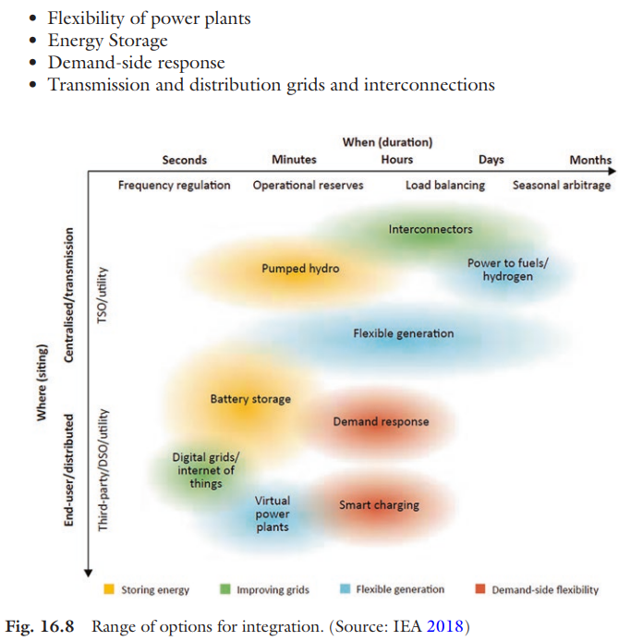


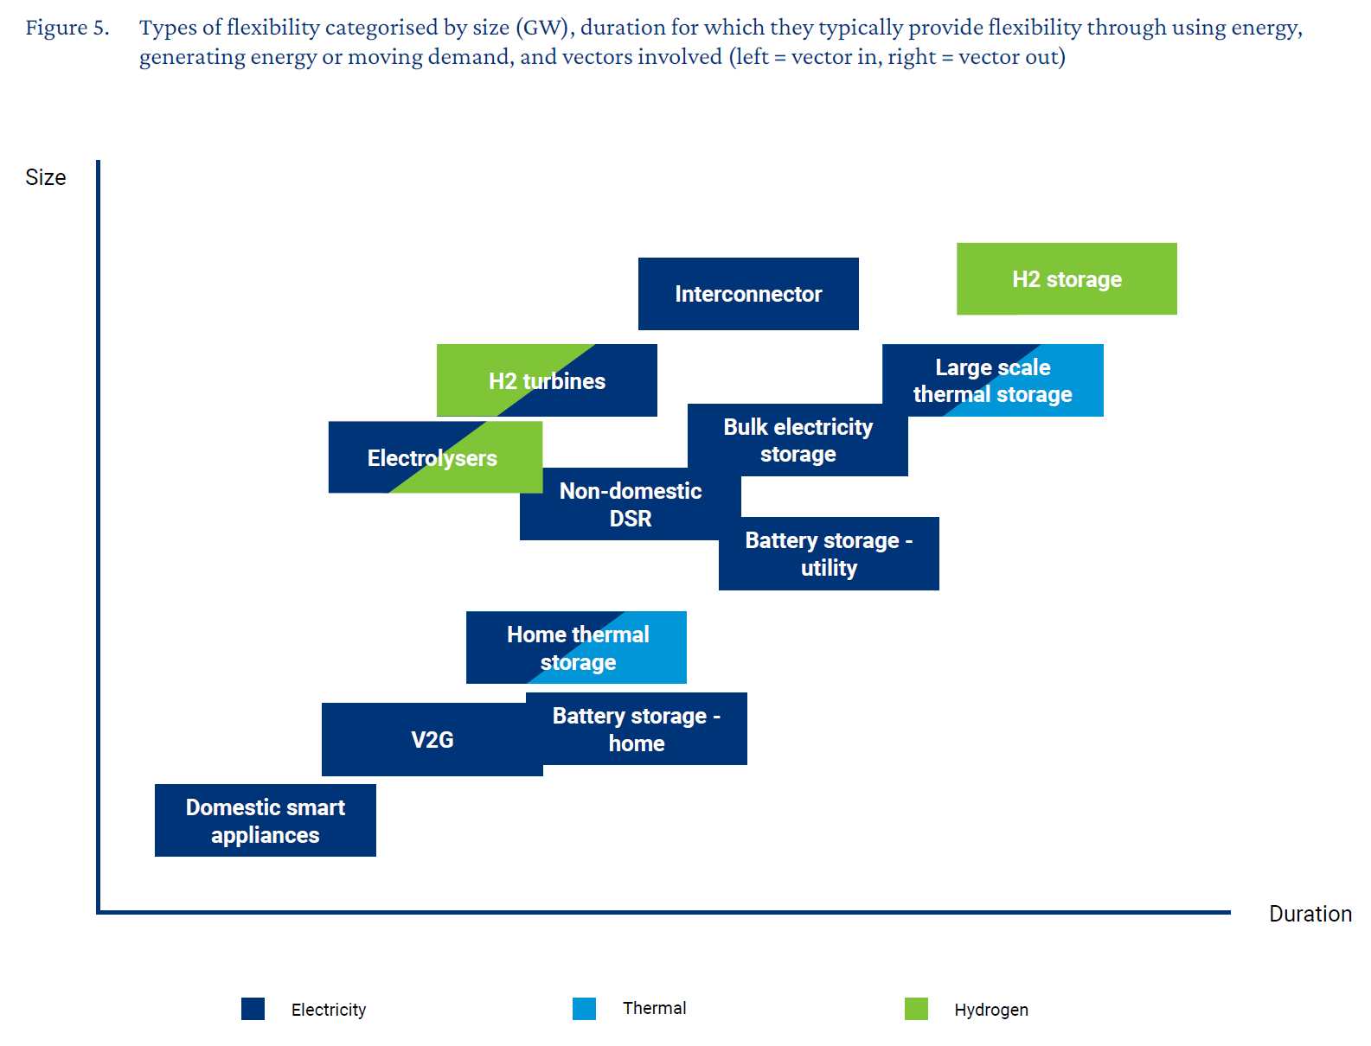




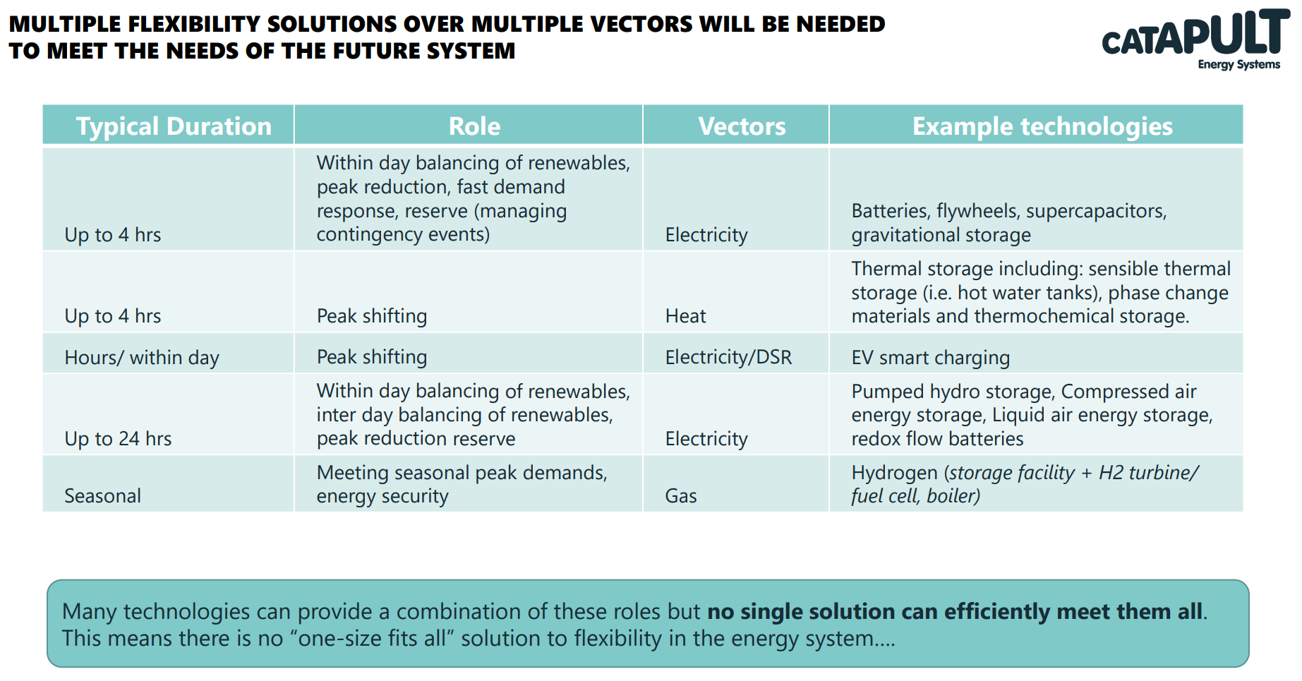
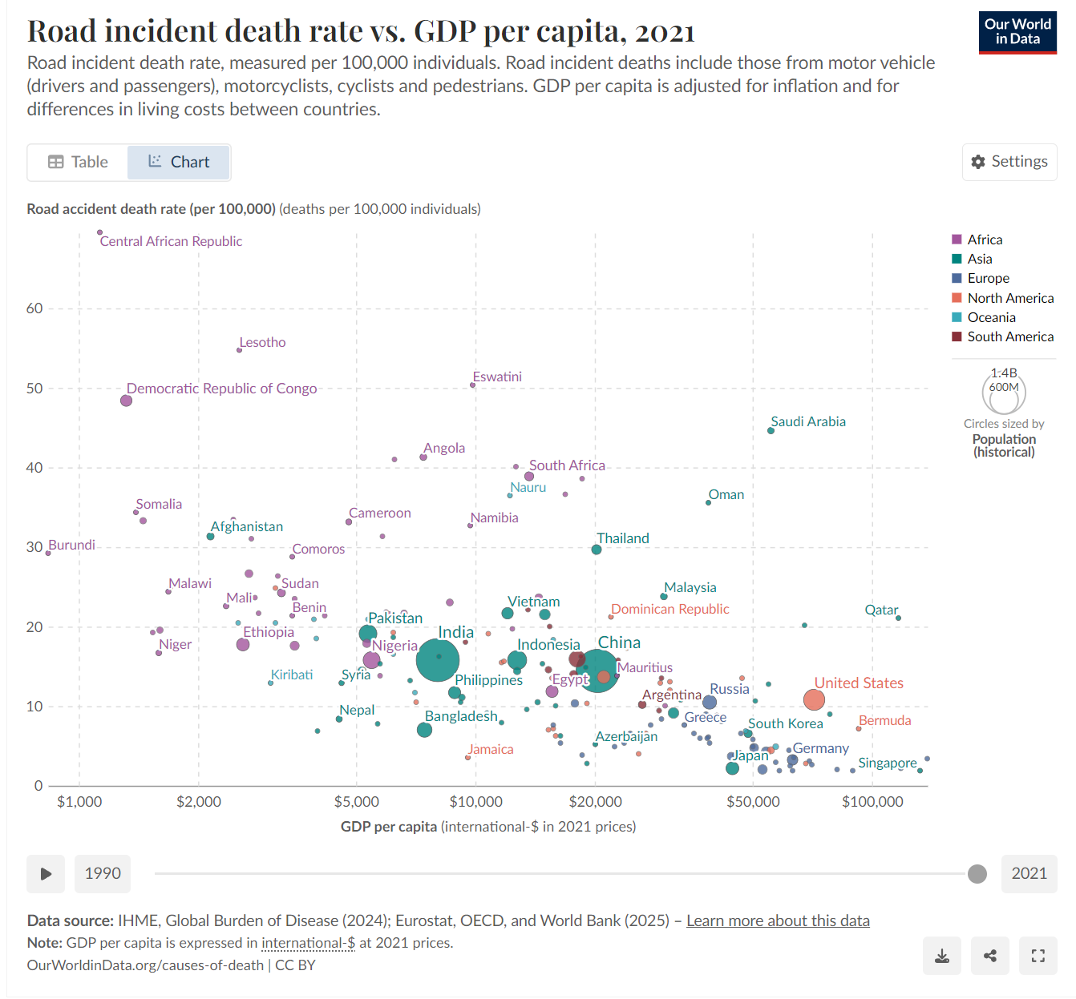

Whole-System Approach for Clean Energy Systems
Our Whole System approach.
https://www.nationalgrid.com/electricity-transmission/our-future-network/our-whole-system-approach
We’re working to build a fairer and more affordable energy system, with Whole System at the heart of this approach.
Our resilient Whole System approach
https://www.nationalgrid.com/document/344151/download

Facilitating Whole Electricity System Outcomes
https://www.neso.energy/document/119416/download

The importance of a whole system approach to energy
https://www.neso.energy/news/importance-whole-system-approach-energy
“A whole system view across electricity, gas, heat and transport underpins a sustainable energy transformation. Widespread digitalisation and sharing of data is fundamental to harnessing the interactions between these changing systems.” That’s the fourth message of FES 2019.

Whole energy systems
https://www.ukri.org/what-we-do/browse-our-areas-of-investment-and-support/whole-energy-systems/
This research area aims to develop cohesion and understanding of Whole Energy Systems and specifically the whole UK energy system.

Upgrading Our Energy System: Smart Systems & Flexibility Plan
Whole System Approaches for Smart, Flexible Energy Systems
https://www.exeter.ac.uk/v8media/universityofexeter/research/microsites/exeterenergy/Edward_Nelson_-_BEIS.pdf

Taking A Whole Systems Approach To Net Zero
Exploring how the UK could design the future energy system
https://www.centrica.com/sustainability/our-journey-to-net-zero/a-whole-systems-approach/
https://www.centrica.com/media/l25bguiv/a-whole-systems-approach-to-explore-net-zero-pathways.pdf

Whole System Approach
In the past, providers of electricity, gas, water, industry, transport, housing, and local services (among others) made plans independently. Now, net zero targets drive the need for these providers and others to collaborate across a ‘whole system’ that accelerates the decarbonisation of society and delivers services more efficiently.
https://www.ssen.co.uk/about-ssen/dso/whole-system/

A SYSTEMS APPROACH TO DELIVERING NET ZERO: RECOMMENDATIONS FROM THE PRIME MINISTER’S COUNCIL FOR SCIENCE AND TECHNOLOGY
https://assets.publishing.service.gov.uk/media/5f3d315e8fa8f51747a88083/cst-net-zero-report-30-january-2020.pdf

A Whole System Approach is critical for energy networks and regulators to support decarbonisation efforts
https://www.eca-uk.com/2022/03/23/a-whole-system-approach-is-critical-for-energy-networks-and-regulators-to-support-decarbonisation-efforts/
https://www.eca-uk.com/wp-content/uploads/2022/03/ECA-Insight-A-Whole-System-Approach-is-critical-for-energy-networks-regulators-to-support-decarbonisation-efforts.pdf

Flexibility in Great Britain
The Role of the National Energy System Operator in Delivering the Energy Transition
Accelerating the transition to a flexible, low carbon energy system ESO RIIO-2 Business Plan 2023–2025
ENTSO-E Vision A Power System for a Carbon Neutral Europe 10 October 2022
Call for Input on ESOs Flexibility Markets Strategy May > Friday 28th June 2024
Introduction to energy system flexibility What is flexibility and why do energy systems need it?
Cost-efficient decarbonization of local energy systems by whole-system based design optimization

